**Phase 63**

And its impressions are increasing and chances are people liking it people use this type of technique but teacher does not recommend this.

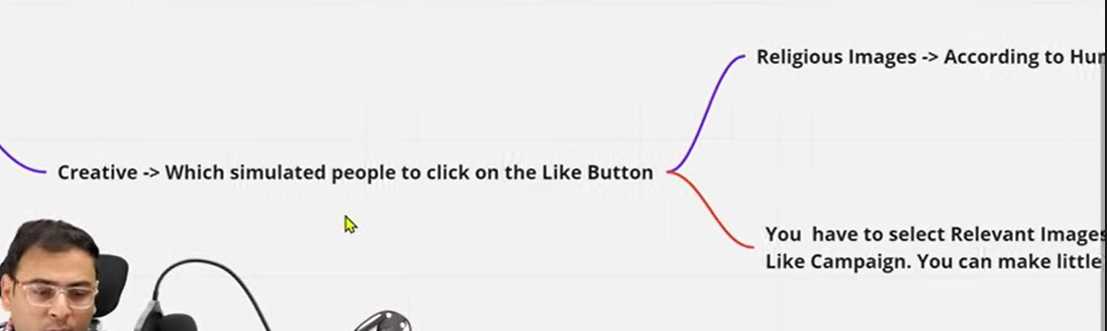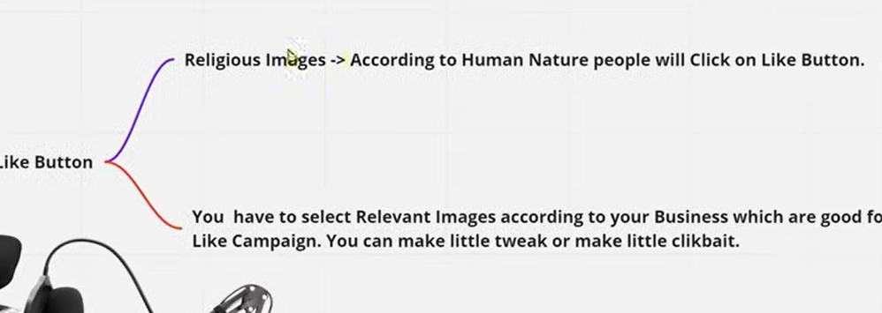

It is recommended to make your creative a clickbait

So if we play with audience and creative then you can reduce your cost of bringing like to your page

So test different different audience and different different creative

Now we will see how to do this in our campaign

So create an engagement campaign as this is the place where you create like campaign

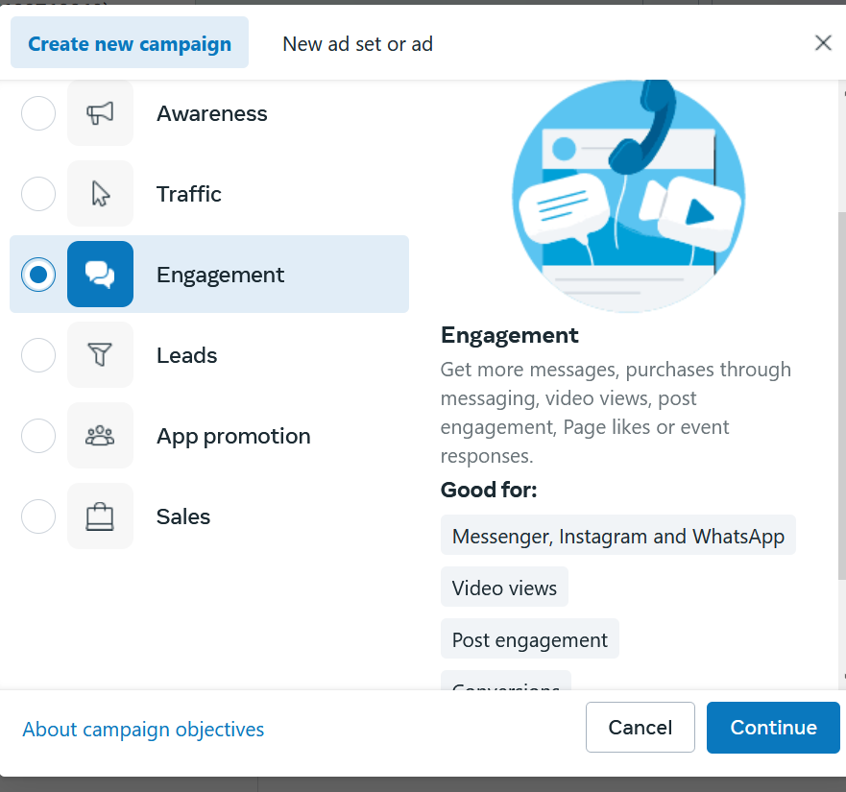

And then click on continue

You will use lookalike audience in this campaign

So what we are saying we will add ad group In our campaign each targeting lookalike audience from different sources

Suppose for one ad group we are targeting one lookalike based on our website visitors

Amd then we make ad group using lookalike audience based on the lead form

So we will create different ad group inside this campaign where different sources lookalike audience will be there

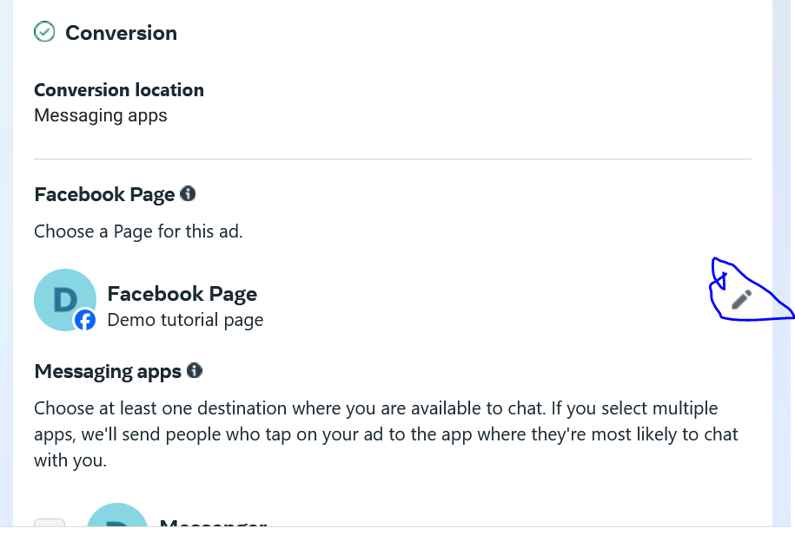

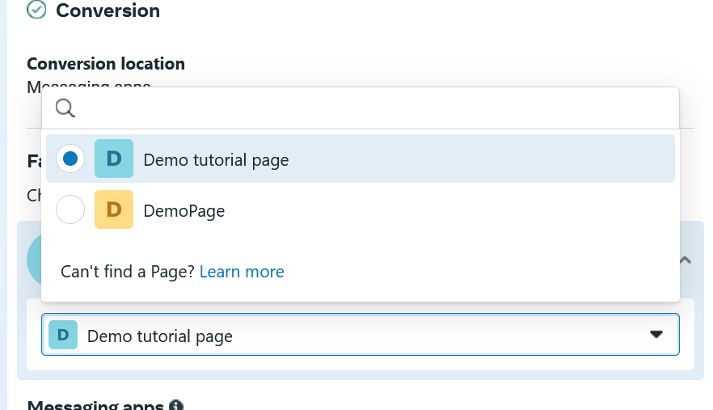

Now choose the page you want to increase the likes of ass you can see above by click on the marked above you can change the page

We name the ad group on the basis of lookalike audience we make

From Teacher perspective

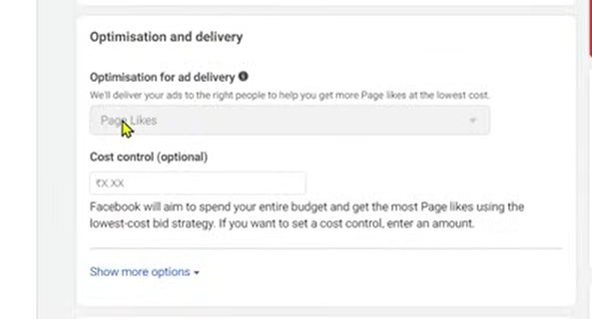

We are not touching optimization delivery because

It is good that page like is optimised is good

We set its budget you can set it according to your strategy and budget

Now choose your lookalike audience as shown below

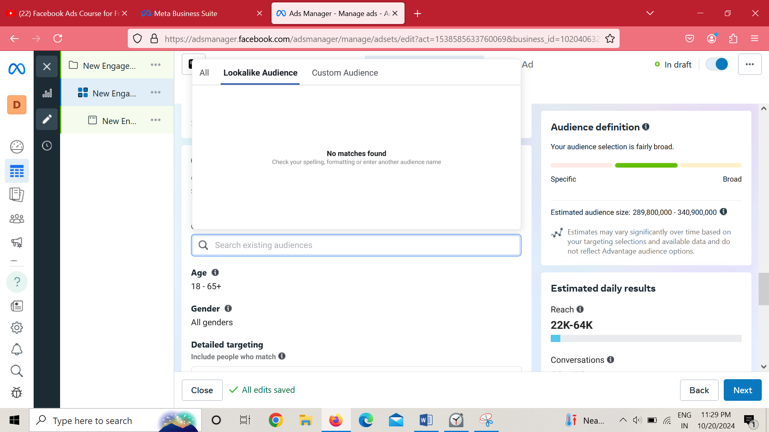

If you want to be location specific then you can do so.

Don’t think that by making only one campaign then you will become successful,it will not work

The more early you will understand this the better the marketer you will become

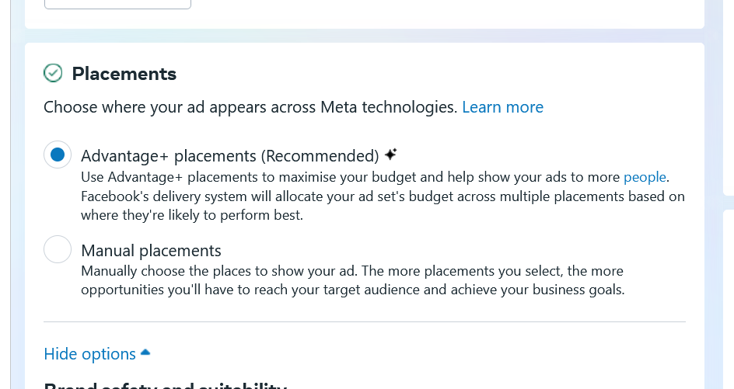

We keep the Placement automatic in case of like then next

Upload your creative and then write a small primary text here

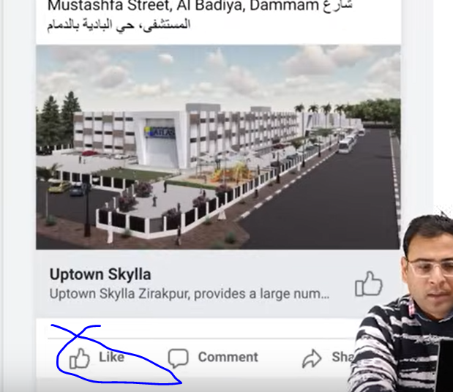

You can see the like button in preview as marked above

The content of creative will not be normal because here you want to encourage the people to like the page and related to it you have to post the content

Lesson 52:-

In this lesson we will learn about **Complete lead generation campaign**

From basic we will lsee how to create our lead campaign

If I tell you how to create lead generation campaign then it is a technical process

We understood that we have to do some campaign level setting and then ad set level and the we have to create our creative then we need to create form and then through which we can capture our lead

This is the process that we will discuss

There are two problems in lead generation campaign that is very important to master lead generation or from there generate profitable leads.

Now when we say profitable leads now suppose I say I am getting lead in 3 rupees and you become happy that you are getting very low cost per lead and then tehr eis person who is getting 50 ruppee per lead then it is worst lead and 3 rupee lead is good

So generally if you have only that data and you have only listen then you will think think rupee 3lead is good it is running campaign In a better way he has more knowledge of lead generation campaign but if we talk from the marketing point of view then this thing does not matter that much but more important is quality of lead suppose we take an example

Now suppose 3 ruppe person 100 leads then he spend 300 rupees and quality lllead from them were only 10. Then in 300 ruppee we get 10 quality leads then I will not say that he was getting 3 rupee per lead that not how teacher calculate

Now there is lead and then there is qualified lead to understand it we take an example

In 3 rupee lead you get 100 lead so total spend is 300 rupees

And among it 10 were quality lead so quality lead cost is 30 and actual cost is 300

Now if are getting lead 30(default quality lead as high cost) rupee lead and get 10 quality lead

So ther cost is 300 which is ame as the previous case

So first remove it from your brain that the determining factor in leads is cost of lead by this you get only satisafaction that you are getting less cost per lead

If I do very wide and u=irrelevant targeting then I get leads in 1 or 2 rupees but what will be the meaning of those leads when they are not quality leads

SO for whatever business you are advertising for how long you can stop them hus other resources will be wasted

Now suppose you bring 1000 leads now he will make the calls on 1000 leads by its call centers and then respose it and will talk to them

And then many people will say they have not even filled the form.

**Phase 64**

There is a constant problem in lead generation when the people is called they discsrd the fact that they filled any form ot hey day you are calling wrong person

We will discuss the in this lesson

The main point is not running lead generation campaign properly . The real point is of running profitable lead generation campaign and its not definition is not getting low cost lead

Its definition is How much is ROS and how much is ROI

And what is our lead to convergence rate. These things are important

If we simply talk about flow of lead generation How lead generation campaign is formed

First we will see the flow and then we will talk about impoertant things

So we first go to campaign creation window

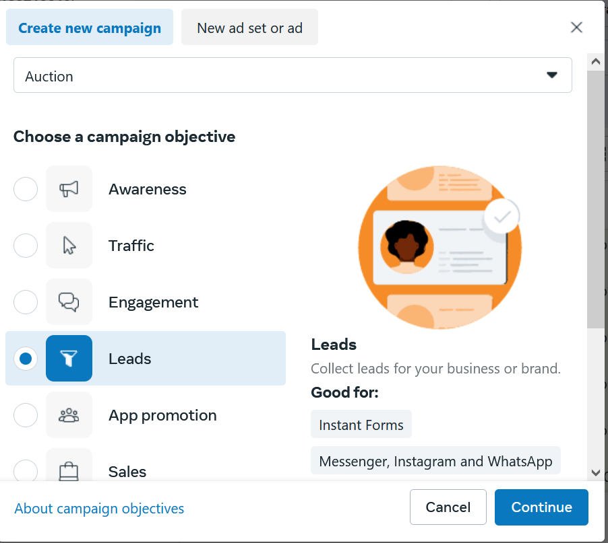

We choose leads and then go to continue

Now when you reach ad set level

From Teacers view

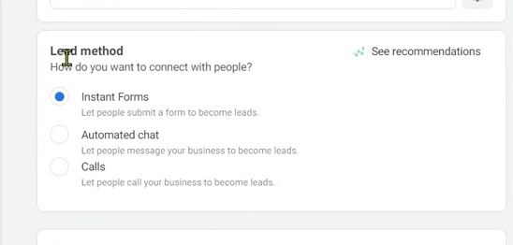

You will be presented three option but we will study about instant forms

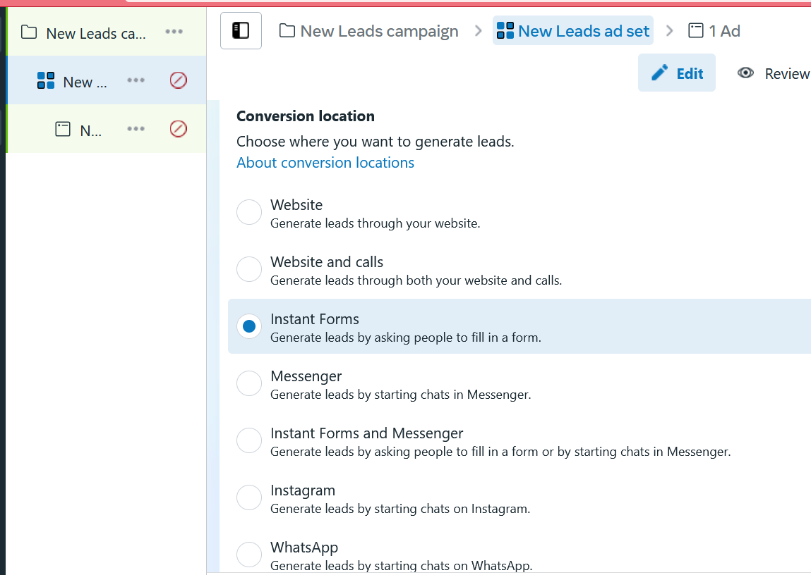

Now in modern UI it look like this.

In instant Form when your targeted audience will click on the ad then a form will be opened so that the person can tell his details

When they fill the form then we get the infoemation in form of lead and then we can further communicate with them

In this lesson we will discuss about campaign setup as well as problems

Lead generation is of two types

They are run for two purpose basically

First purpose is that you have your targeted audience means suppose you are some real estate business your flats are ready and you want to target people who are finding real estate or searching about home or flats. You can target them

In such cases you can create your creatives you show offers and tell that what is your project . Where is your apartment location and then you will give form to them so that they can give their details and our team will contact with them

The second purpose to run lead generation campaign because we want to capture the lead and then we can nurture that lead

By nurturing we understand Here we don’t have any instant things to sell them but we want to bring them in funnel So that we can repeatedly tell them about our different different services and influence them.

Since we don’t have anything to sell instantly so we use lead magnet

Now suppose if we want to target people who are interested in digital marketing I am not generating lead because I have some instant course or services I want to sell it no

I just want to keep the details of those people in my data base because I know in my funnel there are lots of things which we need to educate and aware them

The leads are rich leads By rich leads we mean from quality point of view because if I go in open and target people who are interested in digital marketing then we can say it is not a good quality if we compare it to we want to target those type of people who are interested in digital marketing and they also have taken my free pdf in the form lead magnet

A lead magnet is a free or discounted item or service that a company offers to potential customers in exchange for their contact information

So this is another type of lead generation campaign

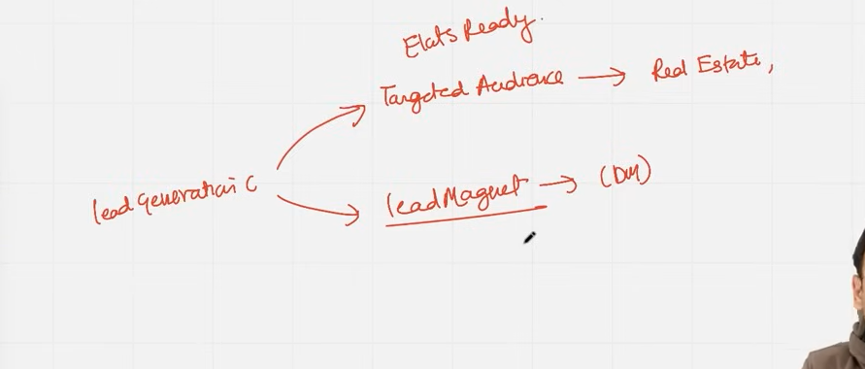

These two types are based on the Teacher’s experience

So first if youwant to sell some direct services /Product then you can run lead generation campaign and collect rhir information and contact them

I think nurturing means givinf offers in funnel

The seconf type is if we want to collect leads for the purpose of nurturing ->Here we use Leads magnet.

We will talk about lead magnets and why we use it later.

And from the example of digital marketing what can be the different different lead magnet

Now there is another question that lead generation campaign is for what type of business

Lets take an Example where we want to sell a sweatshirt

Now suppose is cost is 800 rupees or 600 rupees

Means any product which has a very low monetory value or low ticket services

If we want to sell them this then we don’t run the lead generation campaign

Because for 500 , 600 product he don’t think about it too much

If he get influenced and he may need it then he will buy it he will not for a 500 ruppees thing will contact with you and your Team resources contact him and will explain the product or services and give thir input in it hence your resources will get wasted.

So it will be usefull when we need to involve telecalling team or backend team or we have communicate them with prospect

In the case of direct sales (Real Estate) if the person is interested in property it is npt like and will not directly give crore rupees the prospect will call you an discuss thw property and see the proper documentation visit the flats 10 times and takes time he make take months

We choose the facebook ads on the nature of the business

If you don’t know any thing about that business then you are in the backfoot

So by understanding real estate you understand that if you have quality leads or good leads

Now whoever had submitted the lead form after the team contact with them and they say they have not filled any form and it I wrong number Now whether the lead was of 2 rupees or 200 rupees it does not matter loss has happened

So here we need to understand that we get quality leads and better leads so that our teams(counselling or calling) can influence them Now if we talk about running campaign for school admission then we have counselling team who will explain the teacher guardian or student

**Phase 65**

What I the facilty in their institute It is a complete processs it is not like that we run lead generation and everything will be converted its not like that

We need to understatn amny things and at the end of the day what you need to keep in mind is are your getting positive ROS or ROI

We will discuss the differen ce between ROI and ROS The purpose of offering lead magnet is that we want to target those people or we get there information or lead who are interested in digital marketing If we see there are many who are interested but there are only few people who are seriously interested

For this we make a lead magnet

Now suppose for this case our lead magnet is pdf and in pdf we mentioned free facebook ad checklist

Now we know if we talk about digital marketing then we have to talk about facebook ads

Now we run a campiagn by targeting those people and now we will make different different ad groups and from testing point of view we will keep different different audiences there and we will show them the creative saying download free pdf of Facebook ad checklist

Now when the user will click on the particular creative then a form will be opened

We can customize this form according to our need to what information we need from our prospect

We will discuss about form and what need to keep in mind in form later

Now when he will fill the form then he will get the link of facebook

Now we get this thing in surety that this person has taken the facebook ad checklist means he is interested in digital marketing and his interest is more serious

So how it does get proved ,by our pdf

As the uiser get the pdf wer get the suroty that it is a qualified lead

This information is qualified information

Now the name and email we get in our leads we can use them in further email marketing tool or we can make there customer list and on the basis of that we can show thwm ad we can make there lookalike audience to whom we will show them ad again

Now you can see how many scope get opened in front of us

Now we need to understand according to nature of business what couldbe our lead magnet

It is not necessary that whenever you run lead campaign you should have a lead magnet you can do so even without them for ecample we have real estate business company and we have flats and we target those people who wabt to buy something in recent times then we will not give them lead magnet

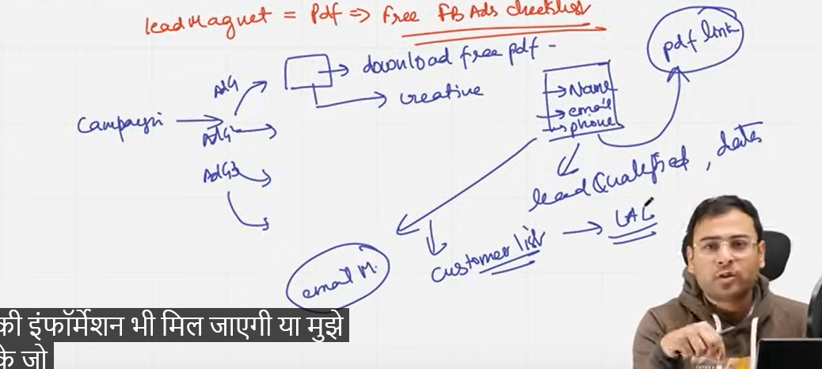

Lead magnet concept comes when you are targeting a very broad audience and it become difficult for you that the audience is very broad and in this I want that I get a specific audience in it. SO for that specific audience we set a condition that we are ginving lead magnet there

I am giving free lead magnet and it is relevant for him then he will surely download it and we will get his information

There are two situations when we use lead generation campaign as discussed preciously

So we are running a lead generation campaign for a real estate campaign

In the naming of ad set or campaign make sure the name match with there purpose you can also add after their name the date of their creation

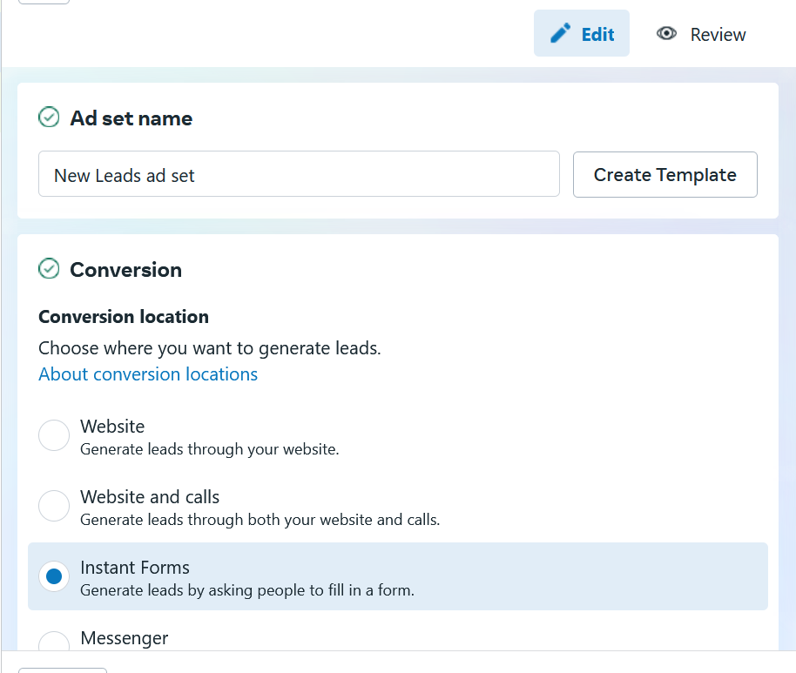

And then we choose instant form in ad set level

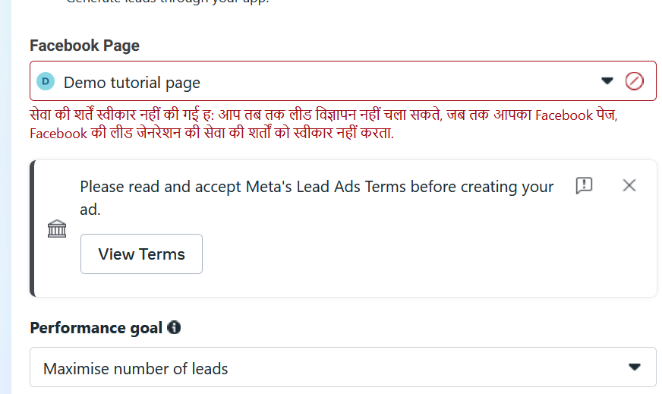

And for what page we are running it we can select as shown above

And now we target the audience we need to keep things in mind that the narrower you get the more expensive the lead will be but the advantage is that your lead quality will be improved.

Here we talked about lead quality Now for the sake of quality don’t narrow the audience too much that your ad does not run properly

Means you have to keep appropriate medium audience set

To improve the quality of lead the teacher will tell us how to do it

Now we keep a saved audience it totally depend on you

Now we go to placement section

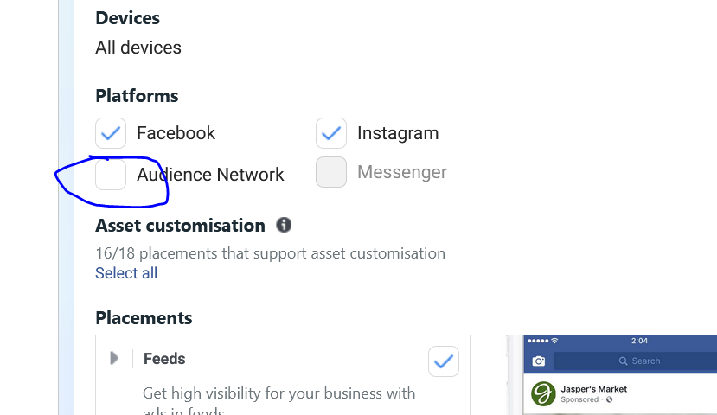

As in manual we get the option where to show our ad

Teacher has observed that in cases where the person say he did not filled any form the lead captured due to them is because of audience network so teacher generally uncheck them as marked above

And he run it mostly on instagram or facebook

There are many ways to improve the quality of lead one way the teacher has told now

By teacher way the fake lead problem get eliminated

And now in ad level we set such creative

The image we add needs to be of the same type as our form is

It should be not like that our creative is giving another message and lead is giving other message

Basically They are not resembling and they are going in different direction

Now we write headlines and primary text, daisplay link (optional)

Call to action depend on what you are trying to offer

From Teacher Perspective

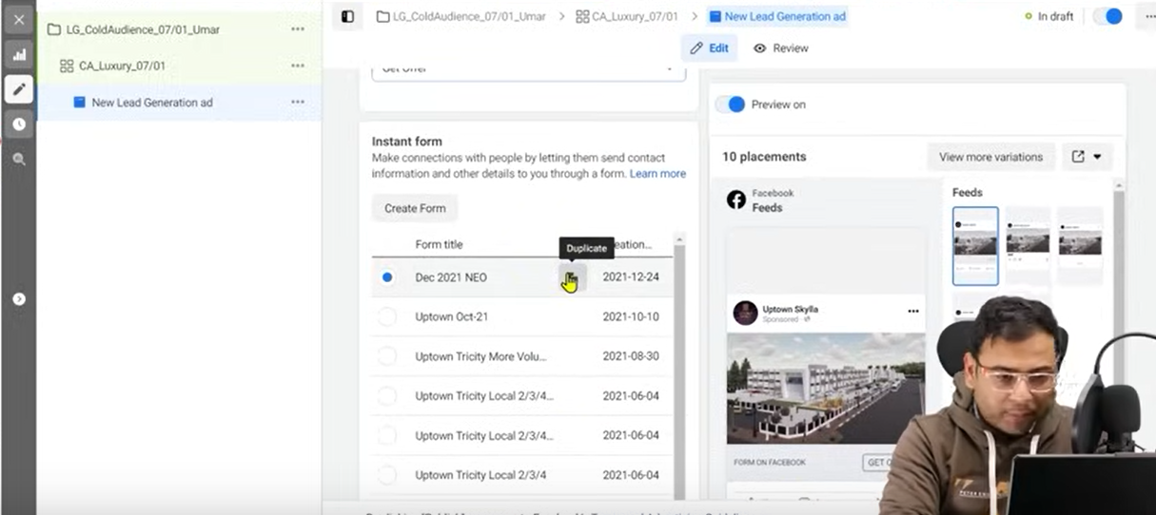

In instant fomr you get different option to create form as shown above

Since I don’t have any so it is not showing option as shown below.

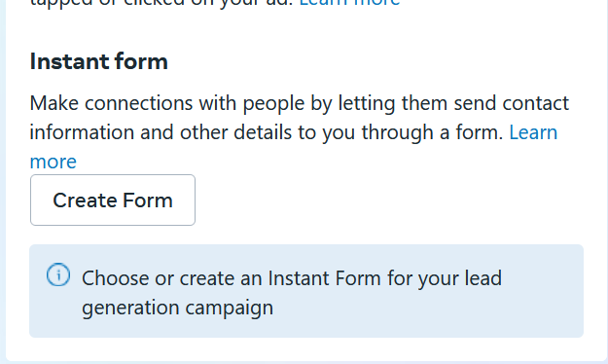

The list is user defined I think so as the pointer is in above screen is clicking on option to create an option duplicate

Now you need to understand how to create a foem so that we get quality lead we need to understand this

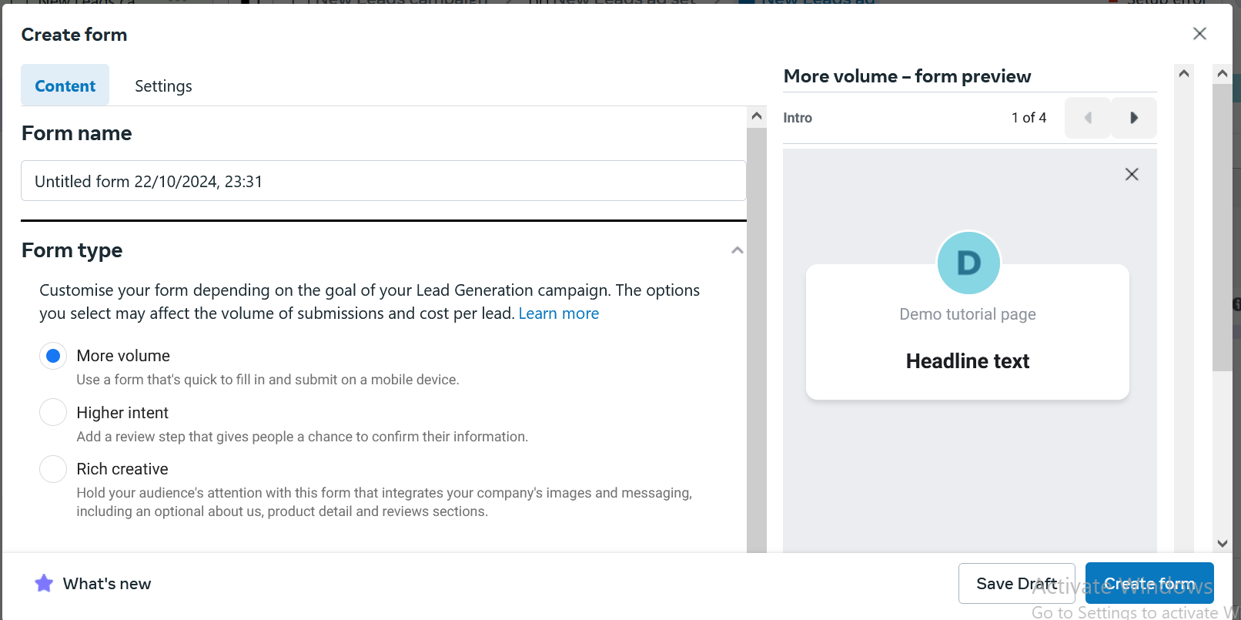

Now tell the name of the form

And then in form type you choose either More volume, Higher Intent, Rich Creative

Means whether you want more and more leads or quality leads

Then how it will be decided when we will get more leads or quality leads.

**Phase 66**

Now when in above more volume is chosen then in preview in the right side of window submit button will be shown below

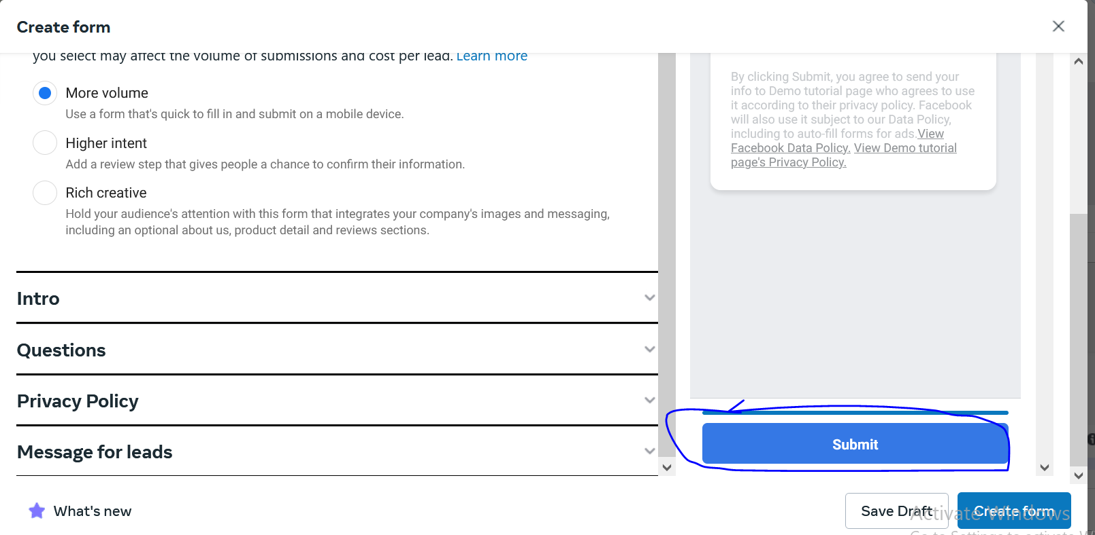

But when you choose higher intent then slide to submit functionality is given as shown below

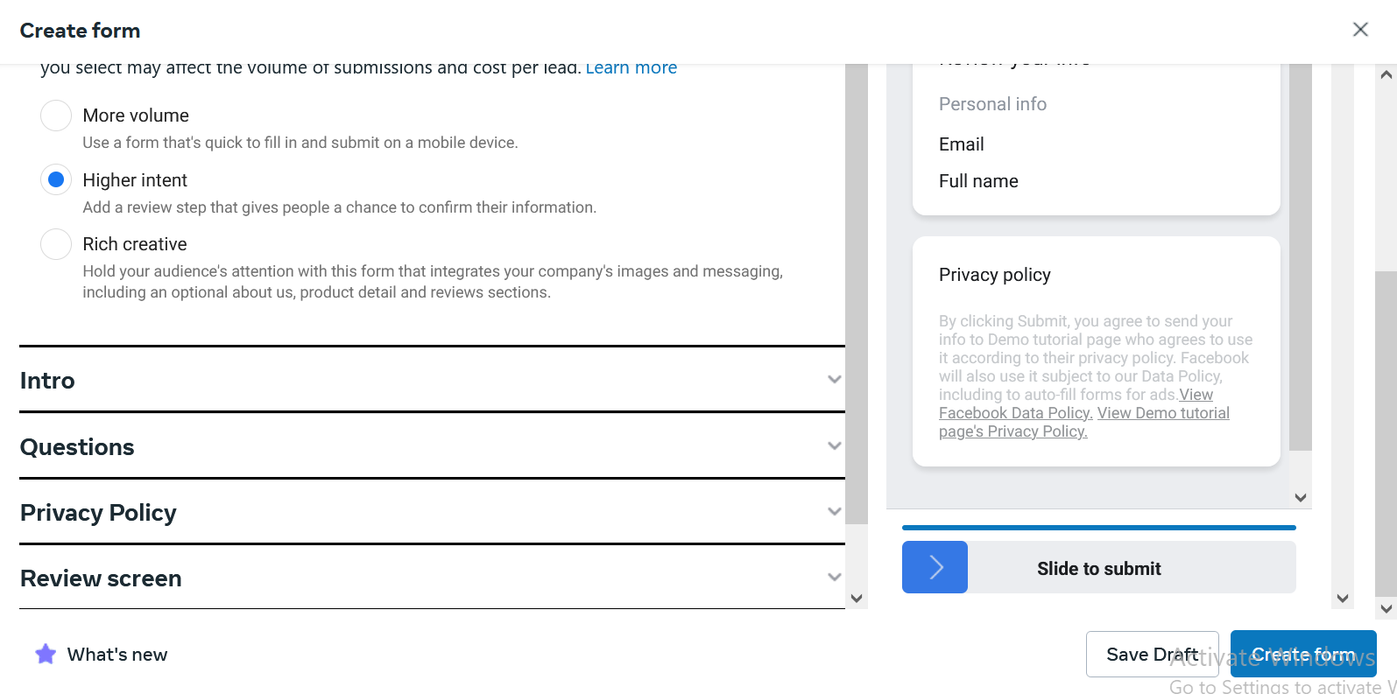

so that we are here indirectly asking to the user are you sure that the lead should be submitted or not

It is sucht he the user don’t fill the information by mistake it just create a mental blockade for the user to think before submitting

It is one thing which can improve the quality of lead.

But drawback is that lead cost will also get increased

If I maintaining positive ROI or ROS then I don’t have any problem with cost

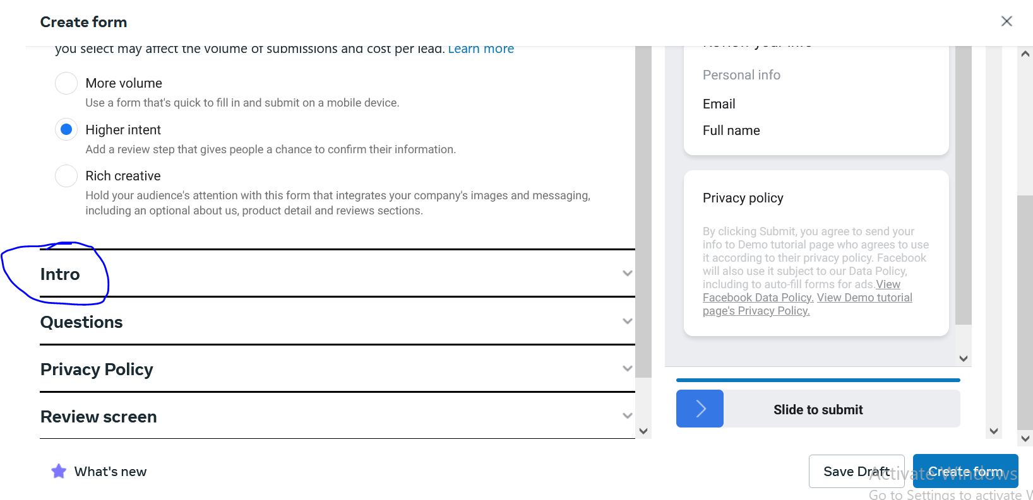

Now we go to intro as marked above and it will be expanded

In intro we get the option of mentioning many things

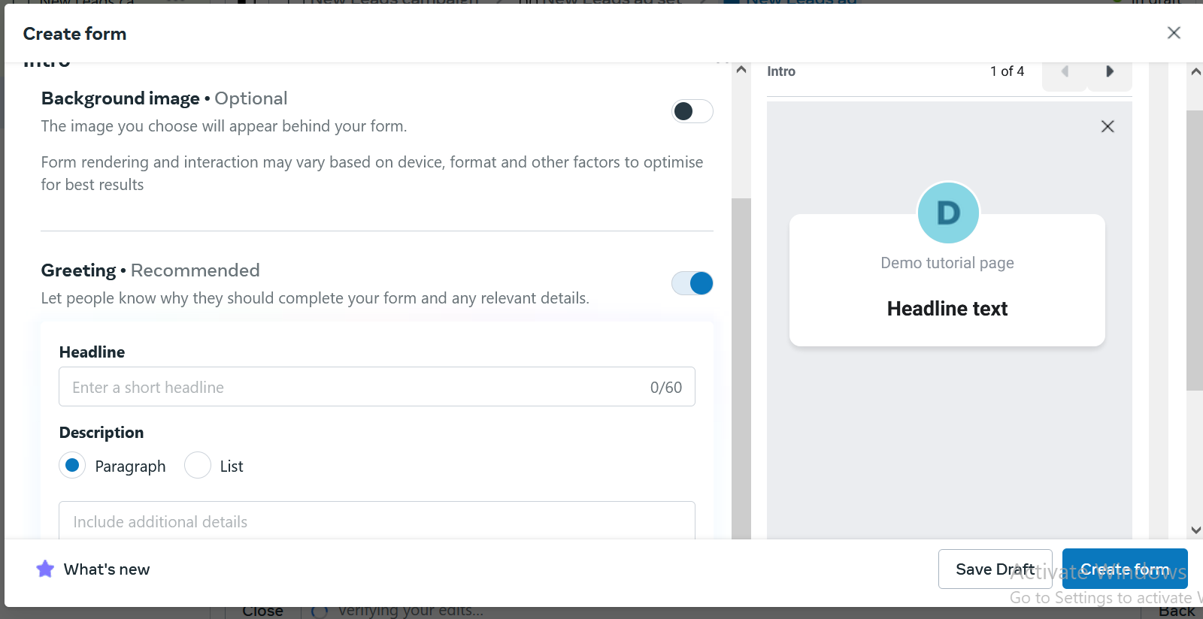

Here you can showcase your offerds , you can show usp here

We get here the option of showing headlines and description which will be shon in our form

Now from teacher perspective in the first slide of preview ther are some option given below the the intro as shown below and marked below

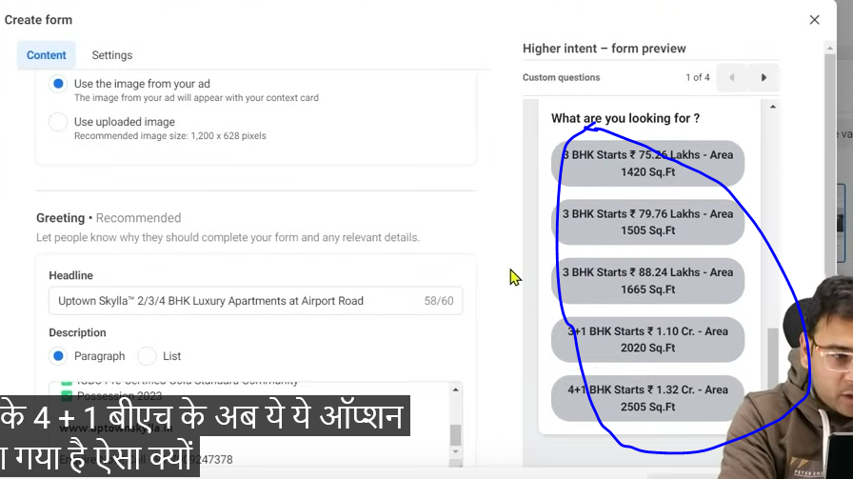

Whn you click on any question then you will move to slide 2

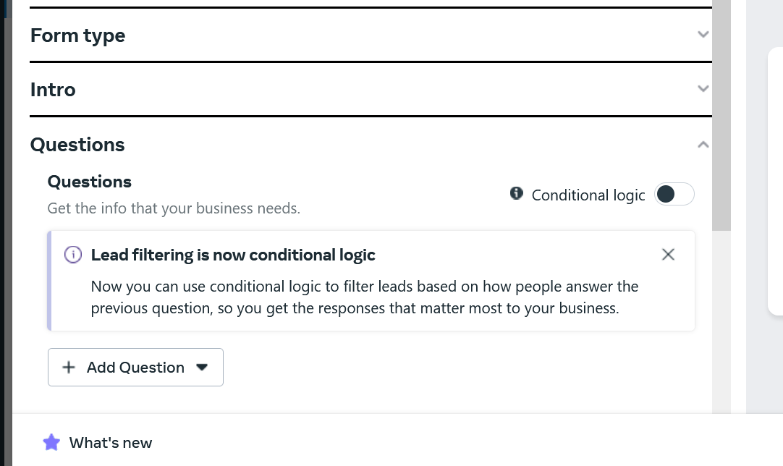

By going to Question and expanding it you can add your own custom question

Many marketers avoid the custom questin but the teacher has mentioned it so that prospect can understand why they are filling the form when they answer the question by choosing any option of the answer.tis means he is interested means we are going towards quality leads

Custom question depend on the nature of the business

If there is school business then we can ask to parents to which class there child is in, what is the age of your child these are the question which will help us to qualify the lead.

But by defaut such question does not exist that’s why we have option to create custom question and how we answer them by clicking on the marked button

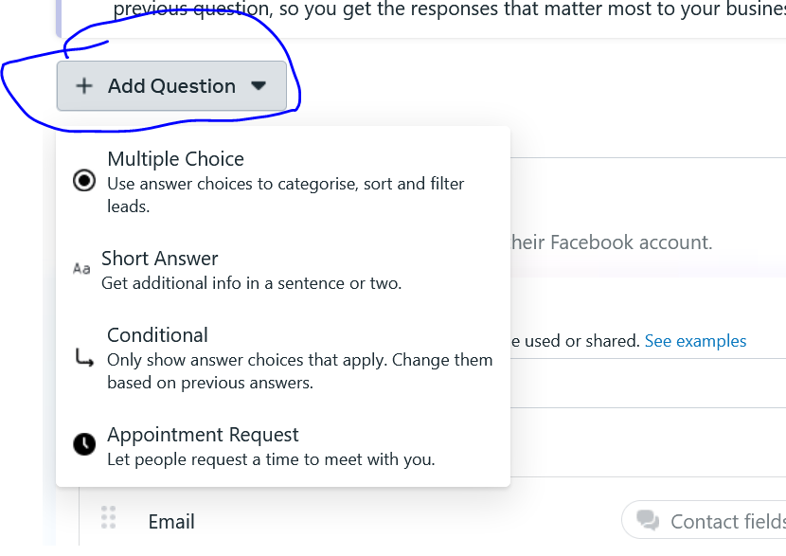

We can answer even on the basis of request of appointment

Now below custom question we have pre filled question as shown below

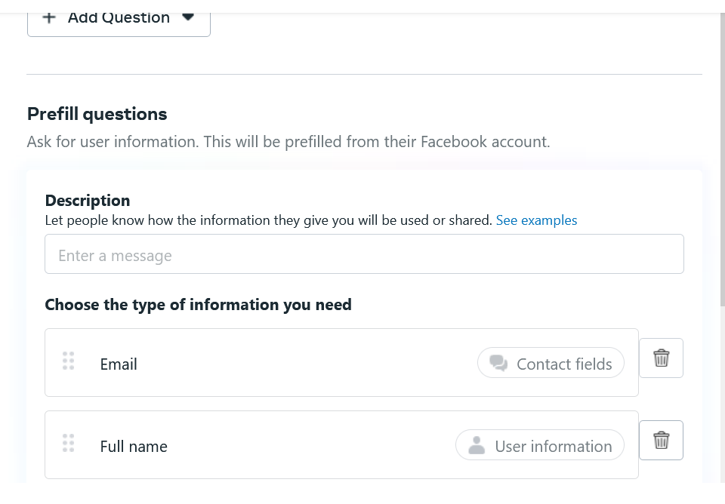

Here is the information which we want to collect form the user.

We can ask them email, Full name

And we can add more categories by clicking on the Add catory button as marked below

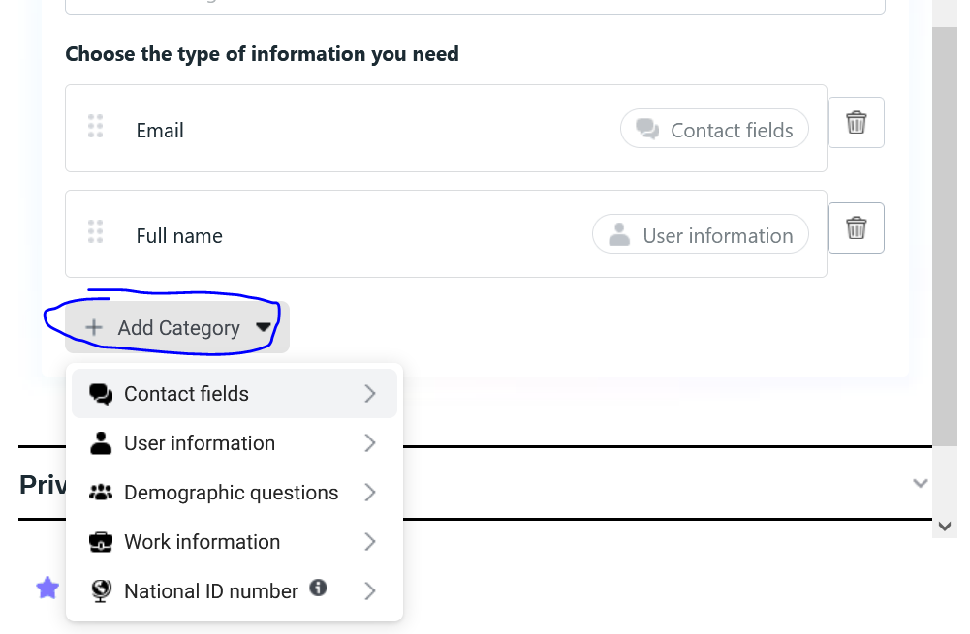

You can ask them of state they live

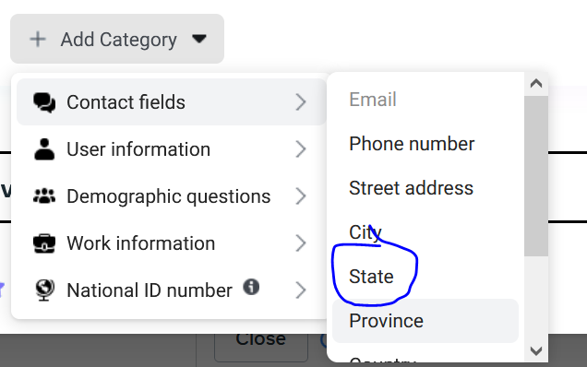

You can even ask the marital status as marked below

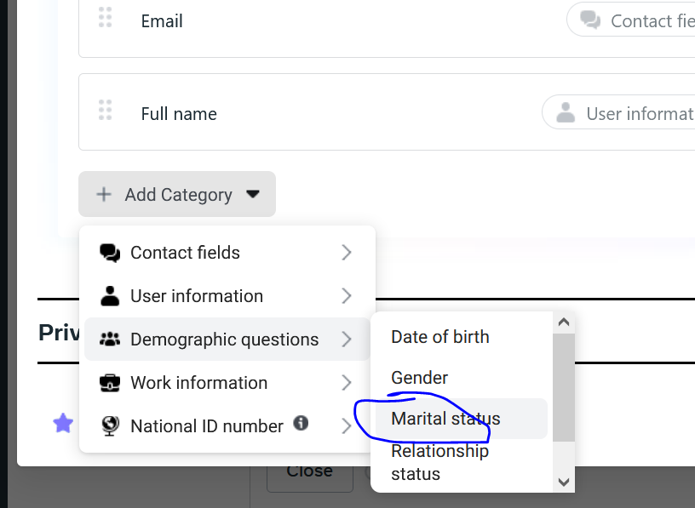

You can even ask them there job title

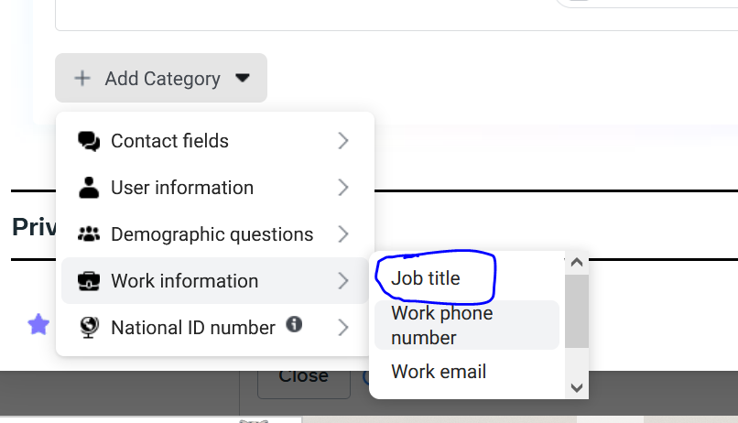

Most special thing is that as the name suggest when this form comes in front of user then all the details of user come there that’s why we don’t get quality leads

Because when the user click on your ad then he only sees the headlines and title

And then below it he sees the custom question but he don’t see the question below he just click on next and then information will be filled automatically and then hee directly submit it without seeing anything and as the form don’t have slide to submit to double check then he will directly submit it immediately The more you make the form detailed (measn detailed question ), The more accurate information you try to collect chances are there that you will get qualified lead

It all depends on what type of form you create

It can happen you make a great form but don’t rely only on one form. You can create different type of form you can test it.

We can duplicate our form and can create many variation of form in different campaign or different different adset or situation for differet audience set

WE can test a form for ane audience set an again later test again on the same audience but with different form.

Now we go to privacy policy

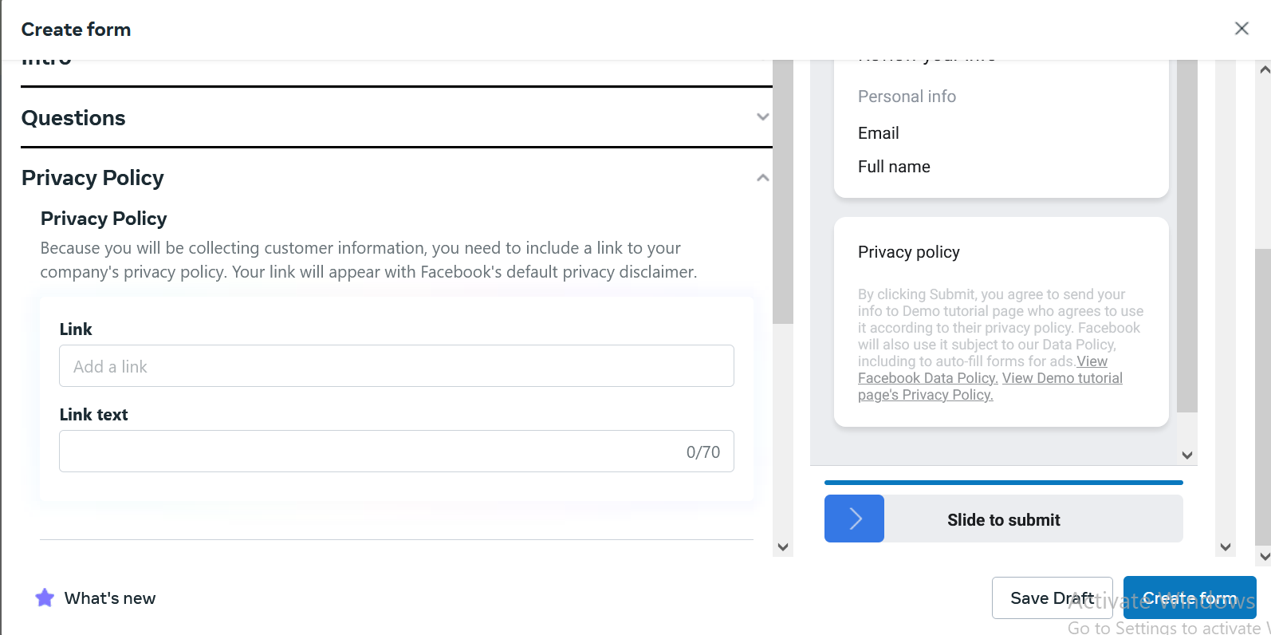

When you do something that you are collecting someone else information then you have to give link of your privacy policy then make sure privacy policy is present on your website.

If you don’t know about it then Google it

There are many privacy policy generator present on the web.

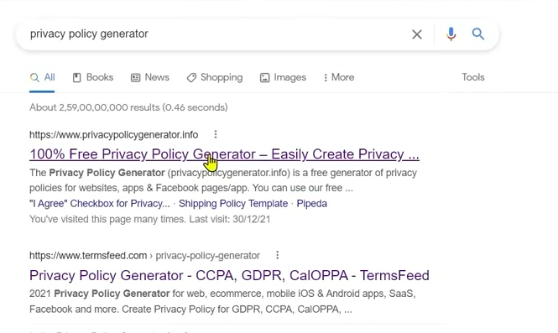

In this generator you type the name of your website and they ask you a very basic information

And they will generate privacy policy for you

Now you may say I don’t have any website

If we don’t have a website then can’t we run lead campaign

If you don’t have any then you keep privacy generated in Google docs.

Then take the link of it by sharing

Now suppose we come to privacy policy

And then make a document there and then paste the privacy policy there.

**Phase 67**

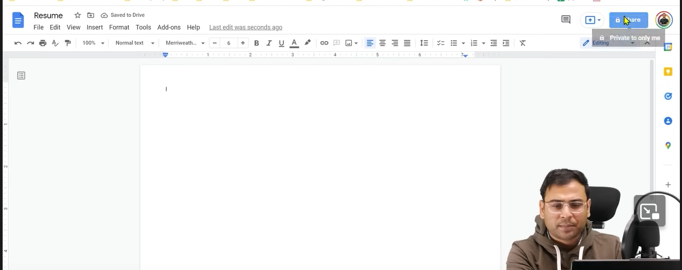

You can now click on the share where your pointer is

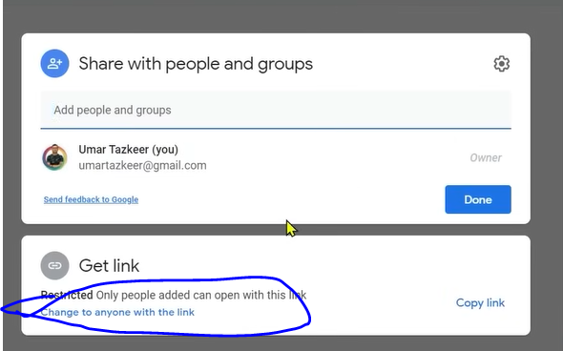

Now in new temporary window click on Change to anyonw with the link

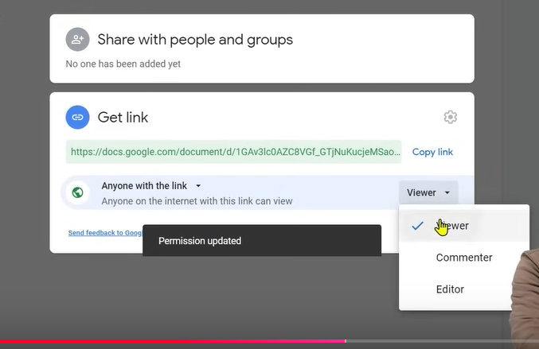

Now choose the viewer and when you ciopied the link By this you make sure whocer you are gicing link is a viewer(only read) (who knows )

Now paste the link in the form window



In link text you tell the text on ehich the user click to go to the privacy policy



Npw you can see it in your preview

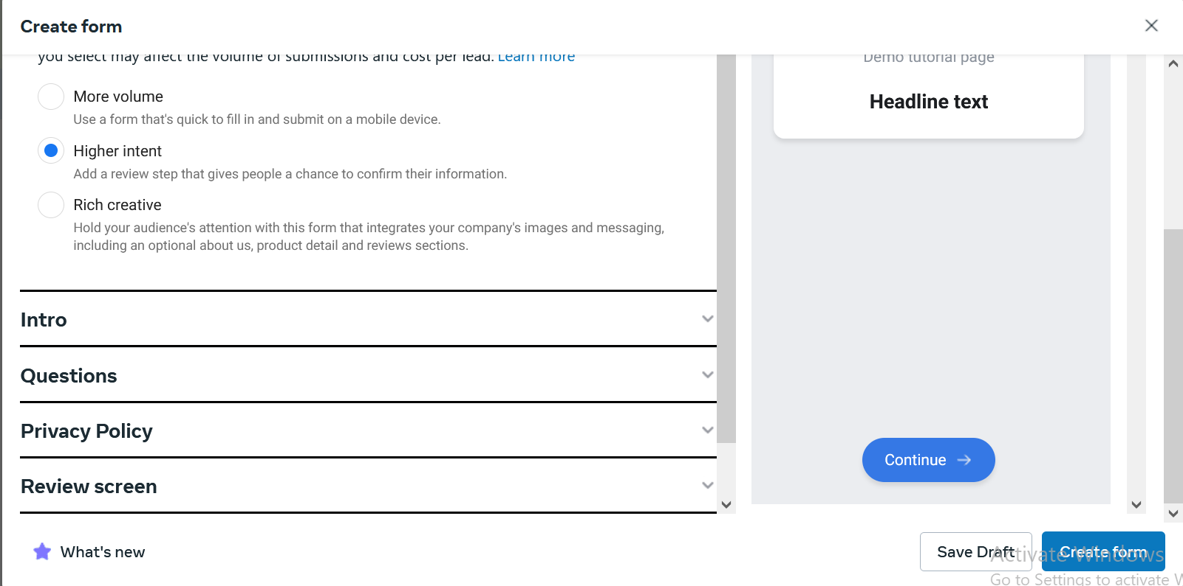

Now the next review screen is because we choose higher intent in form type

Now we got o message for leads(previously called completion)

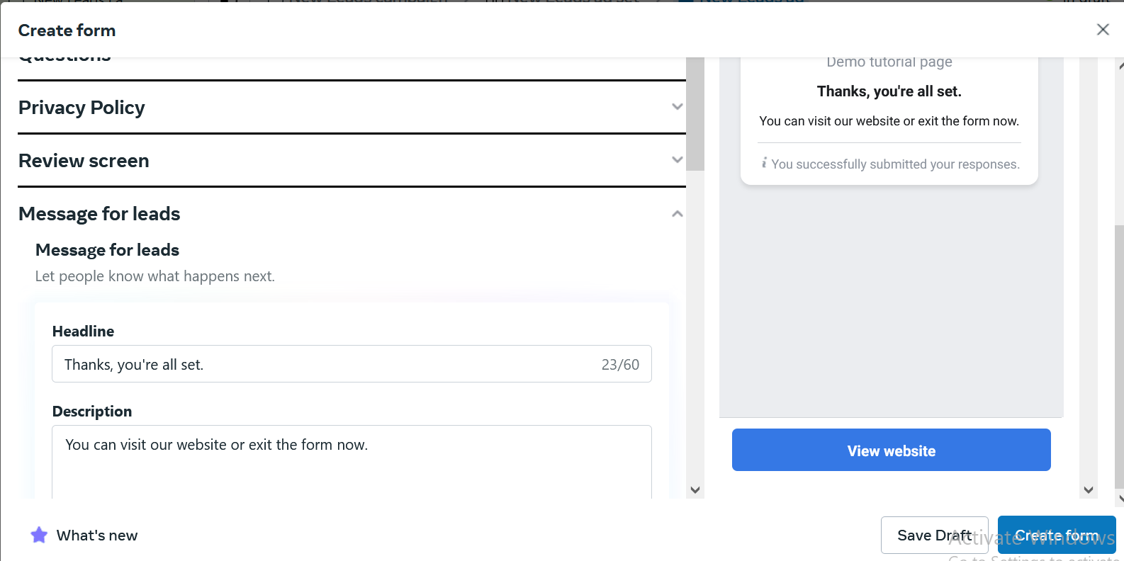

Here we have headlines

In description you write soething like we will contact you shortly you can also write the purpose of your form here

In this we also have a call to action by clicking on which you canmake something downloaded of whatever the link is given

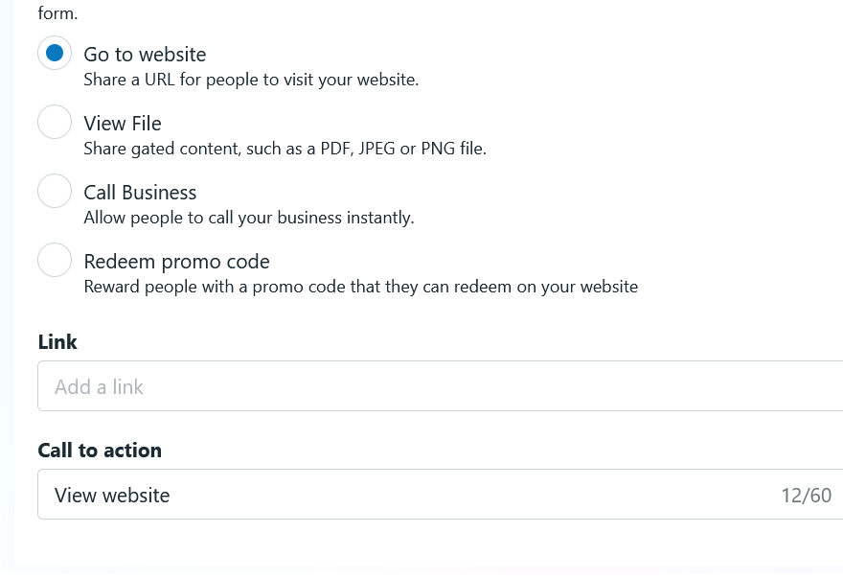

This will be used in the concept of lead magnet

So yo must have understood that audience selection ios important that whether we are keeping the audience narrow or wider which can impact the cost of lead or quality of lead then comes the placement option and how we are building the form

Now suppose we created a form

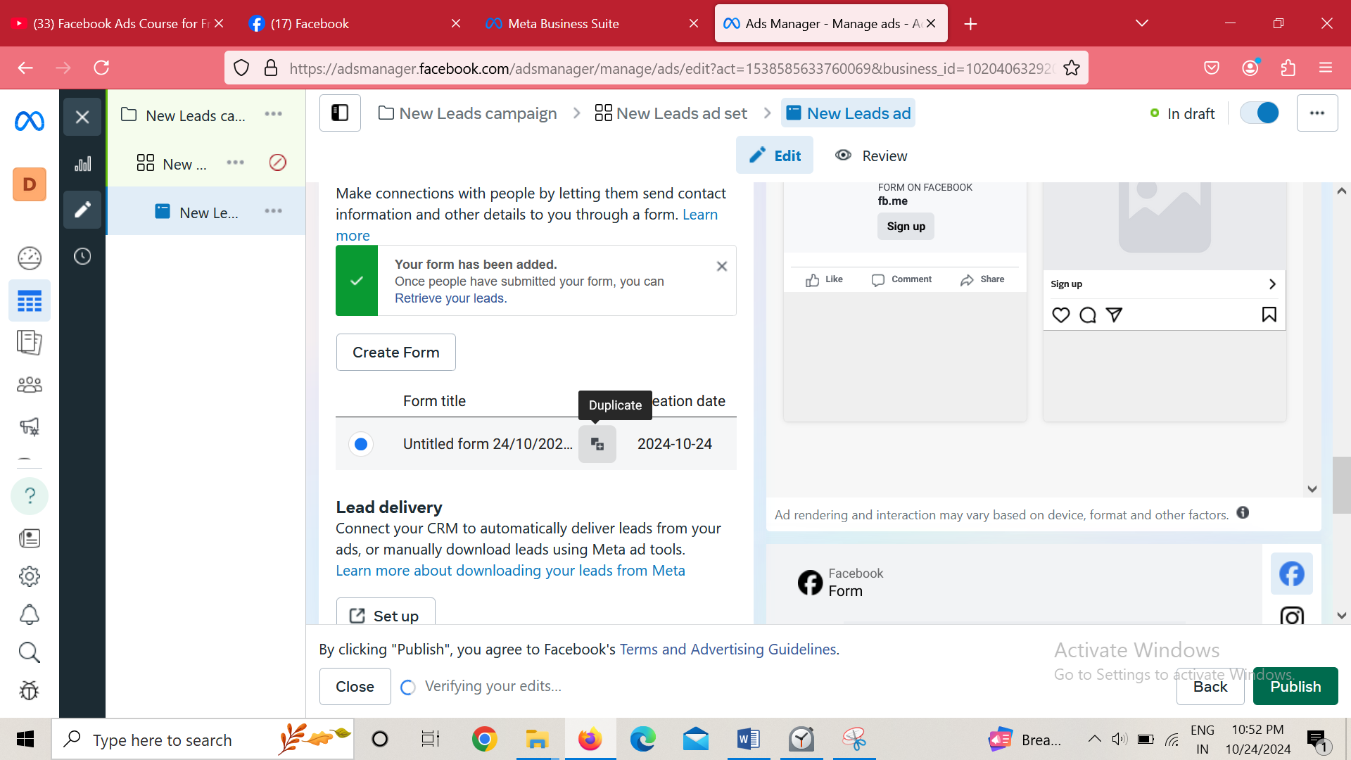

And in the list when we hover over it the a duplicate button will be there click on it to duplicate the form and you can change that form to create a variance of original

Choose the form by clickin on the respective radio button You create frm in ad levl

Now lead form has formed now how to download leads

Now for hat go to your Facebook page. Here have option of publishing tools where you can download the leads form wise

Facebook has given individual to manage lead interface(a kind of CRM) that’s called lead center

From Teacher Perspective(as no lead cmapagin running of mine)

So first we go to Manage Page

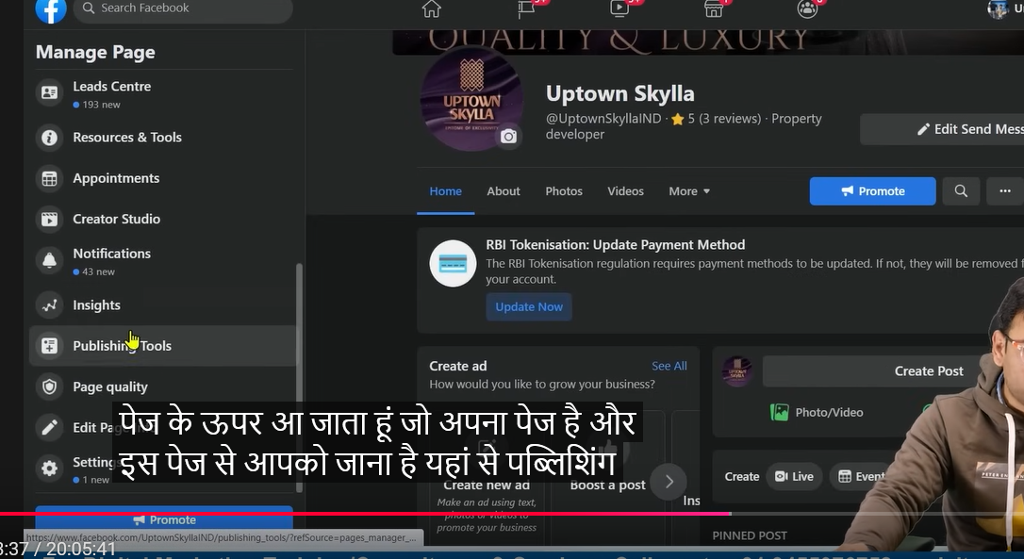

Now choose publishing tool in sidemenu

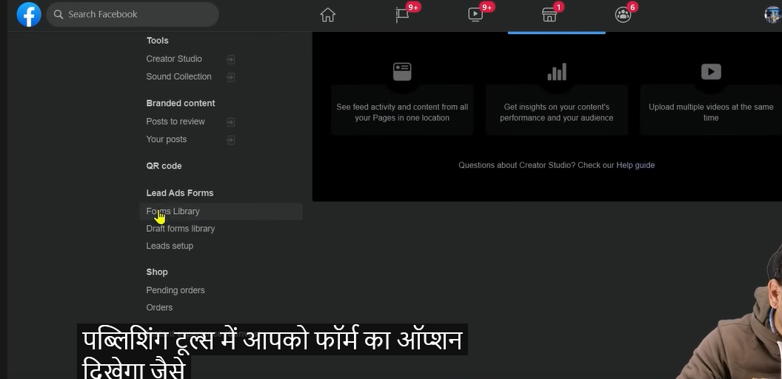

Now then in new page go to Forms library

And then a list will be shown ach item has an option of download

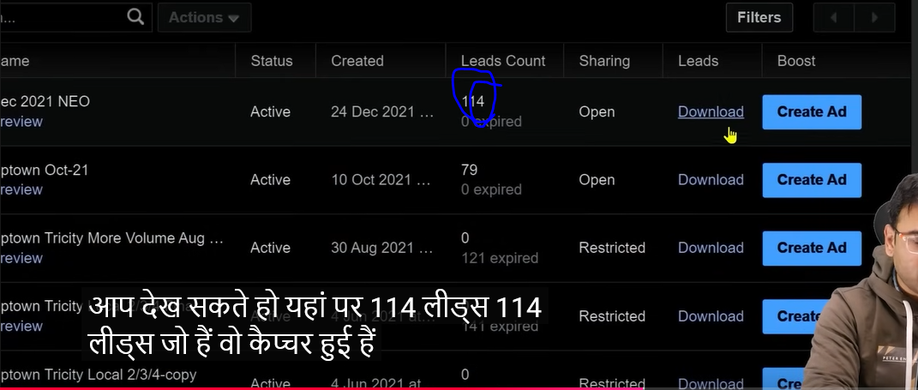

You can see in the list that we have 114 leads

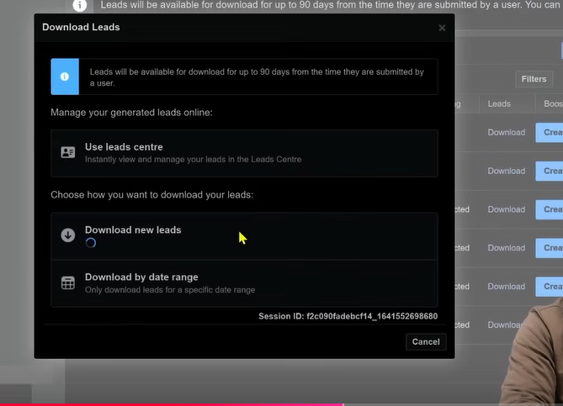

In new panel when you click on the Download new leads

You can tell range of time when the lead was captured and hoe much all tehse are given vbelow

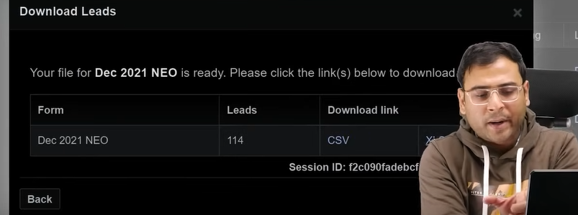

And you can also tell the format here and then you can share thee leads to your team

You can do the automation here

Measn from there it directly go to google sheet

Which we may see in future

IN the page mange menu you also have lead Centre

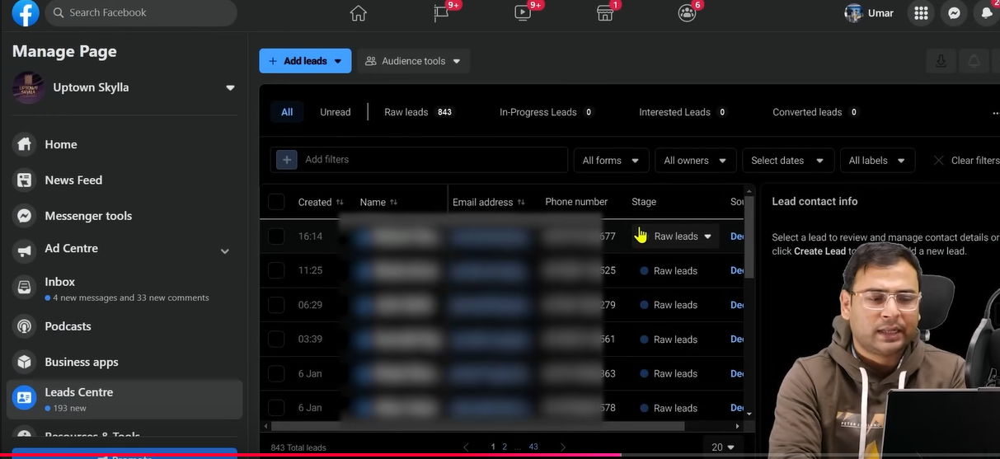

You can see the complete interace below



You can see above is written how many raw leads are there

Here we can attribute leads like we want to send lead to a team member or assign it

WE want togive label like this lead is under consideration or has converted

Facebook has given for everything within the platform has given option to us.

**Lesson 53:-**

In this lesson we will learn about **Facebook Ads Campaign CheckList**

us. You can call it Facebook ad checklist also

You can also call it guide because here we will talk about some important points which you need to focus on if you running campaign on facebook ads for any business

Yo should not do fundamental mistake and do basic miastake

By keeping this in mind this checklist is made

It will make your fundamentals very strong

Now whenever you are setting up some new campaign or for some business you are planning some campaing then make sur you consider these points

The poins has some subpoints also

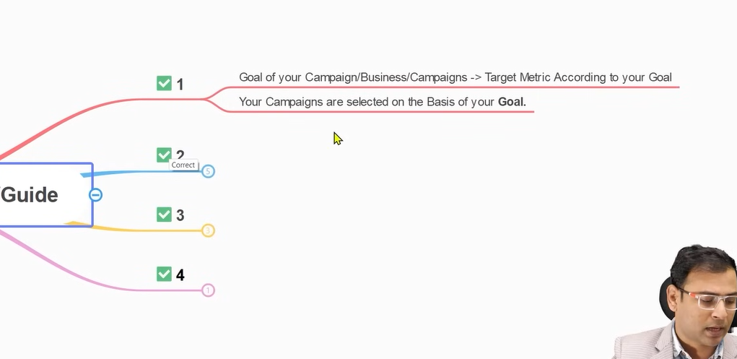

You can see above there are two ponts

One is that the goal of your campaign should be clear and swcond thing is that target metric according to your Goal

Suppose we have a website and we are taking about its promotion

I make strategies such that initially we want some traffic there because we have picel in our website htrough which we can further remarket them

So we understand that we need to create traffic campaign

Then we understand that whatever traffic will come it is not important that all will convert because we are bringing the traffic of cold audiences

So whatever talk we have website owner they sy they also want paralelly leads

So with traffic we parallel will run lead generation campaign for testing purposes

So we understand that for our strategy we need to create two campaign

Now whenever you go to some facebook ad system , you create new campaign there it show different different campaign objectives

In our strategies it is not like that we always run same type of campaign or only n campaign

SO our goal should be clear

And to achieve that what type of campaign we need to run it should be clear in starting

For every campign there is a successs metrics

For example we say for lead generation campaign we measure how much quality leads we get

On tea other hand if we are running convergence ad or message ad then we ee how many relevant message we get or conversion we get

In the similar way if we are running traffic campaign then we will see how many visits were there in our website or how many landing page views are there

We need to decide from the starting that the goal we have and the strategy we made for it

What type of or how many campaign we need to create and according to the campaign what will be our metrics

See according to a goal we have different type of campaign option

If there was only one goal of everything then only one type of option would have been given to us.

**Phase 68**

Why facebook is gving you so much option

Why it is giving so much option because it knows that to achieve a particular goal you may have to run more than one campaign making a complete funnel

SO you should know your overall goal or objective

And you should know the important metrics for that campaign. What is the important metrics for conversion

It will make your fundamentals strong

What people do when they run campaign they get confused

You cannot question that one campaign is better than another

What matters is that what you want

This question should not raised what campaign is better

Both are better it all depends on the nature od the business

And on the basis of that you select the audiences

In many cases where ticket price is high then we try to generate lead

Your campaigns are selected on the basis of your goal

SO before choosing campaign you should have an overall gola in your mind what we want to achieve

In second we have many subpoints

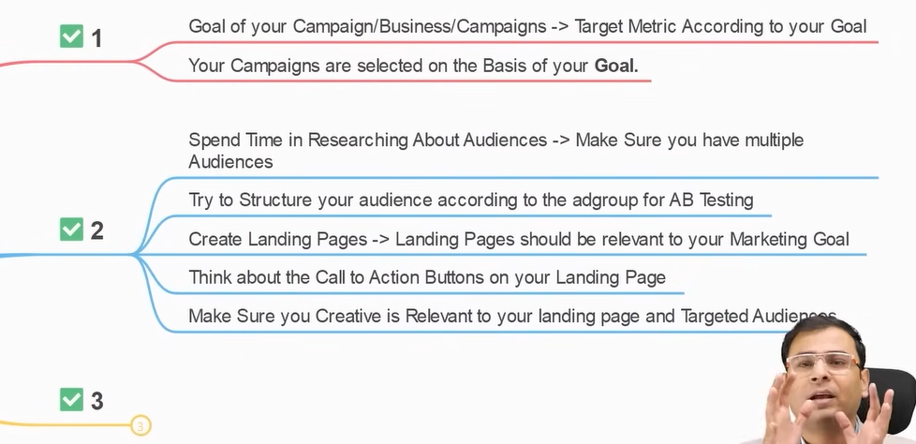

From the testing point of view and the way facebook ad behave from that point of view it is very important that from starting you have learned to create multiple audiences

Don’t do this thing that you make only oe type of audiences and your dependency is on it and if that audience will not run and you don’t have any option

If we talk about saved audience in facebook ad then there are lots of option

You can make audience there on different characteristics

If you say that you tried all the audience and there is nothing more then it will be very rare

Whenever you try to find new audiences then you will get new audiences

SO spend time to research about new new audiences

make different audiences so the when you create your campaigns and add different ad set to it then you can use different creative for different audiences and then test it. SO you have to build this ecosystem yourself

If not ecosystem then you have to identify important resources

It should not happen you make multiple audiences but show them same ad.

The ad shown them should mirror there characteristics

Now suppose we have two people one is engineer

And another is shop owner If we want to talk to them then we need to address their behavior an character then we will talk to them and know ow to communicate with them seperately according to their behavior

So mode of communication depend on the person you are talking to

SO mode of communication between your brand

So the mode of communication between the brand and the audiences is ad copy so you will not made same ad copy for all audiences

SO from this point of view what is important that whatever important resources we have make them ready beforehand or start prepearing for it

Because the mistake teacher see in business is that

They get client approval and they make new campaign select campaign n objective and put random pictures an add random adset and fire the campaign immediately

It takes time in audience research and in enclining creatives to audiences

Now another point is that your goal is different creative is saying something else , ad copy is saying something else Target audience is something else and the landing page content is different mean nothing is relevant nothing good result will come

Make sure that your landing page is enclined toward whatever shown In ad copy through which reach the landing page by clicking on it

Whatever elements you talk in ads should be present in Landing page that can influences it

The next point is unless we tell the person came to your landing page what to do then he will not do it

If you landing page is good but you don’t have good call to action then your conversion will drop.

Make sure your landing page has call to action button

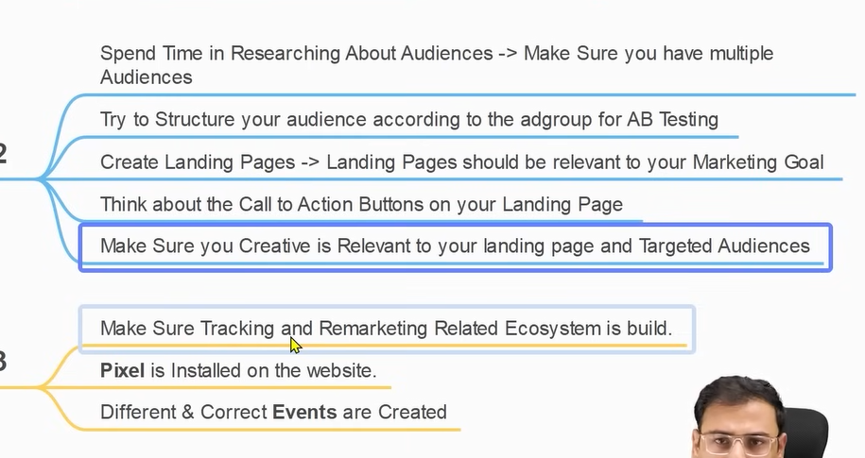

No we come to third point

Why we are talking about this ecosystem

Why we are talking about this ecosystem because this is very simple thing

Suppose you want to add a pixel we add it on our page

Since it is an important part of our checklist

But we have used ecosystem because many times pixel does not track many things by default

Then you have to create many custom event and custom convergence then you will say why we need it . The more events we create the more things we will focus on whether this things happened or not. Form was filled or not.

How much scroll happened

How much people viewed the video in the landing page.

And who viewed it how much percentage they viewed it

So what are these they are different different events

The ecnets we track the more data we have the more type of audience we can create

So again we create a better source of audience

That’s why teacher is saying that you have to build ecosystem of tracking and remarketing

Different and correct event s should be made

Because many problem arises in event tracking

Make sure the evnts in your website are being fired properly or not.

Or the events are properly configured or not

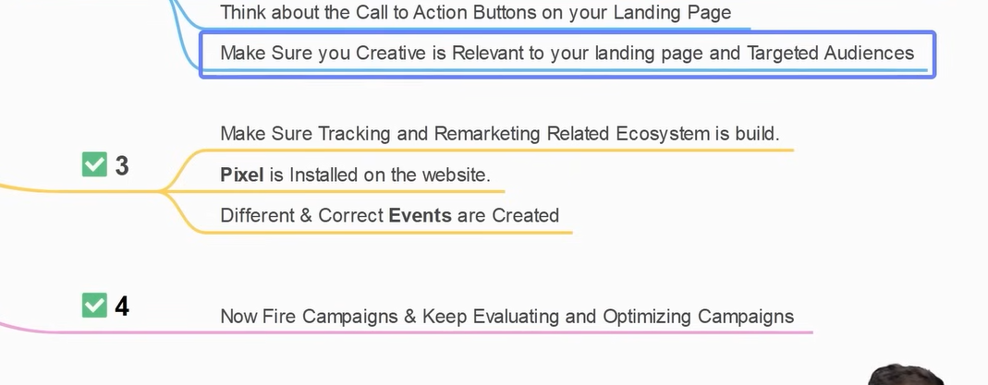

Now the fourth point is which is very important

After doing all these thing you just then fire your campaign and keep evaluating and optimizing campaign always see after collecting some data (maybe from running campaign)

We need to evaluate these campaign and the result we get from evaluation and on the basis of that we bring change in our campaign and we do testing we want to.

When we talk about checklist the most important thing in the checklist is on the strategic level that we need to check is more important

Whether this ecosystem is working good or not.

These things are more important.

**Phase 69**

You can also check you have targeted right placement

But before it the foundation are more important

Make sure you don’t do any fundamental or strategic mistake

**Lesson 54:-**

In this lesson we will learn about **How to generate leads on Whatsapp**

As we know nowadays whatsapp is nowadays used as a communication tool

People not only use It for personal use but they also use it for business purposes only

That’s why whatsapp has introduced its business app

We will learn that how bt running ads on facebook we can derive traffic on our whatsapp and we can bring lead in Whatsapp and capture them through Whatsapp

So we will create an ad and when the person interact with our whatsapp app.

When we say we want of interaction in our Whatsapp or generate leads by it by running on facebook we direct traffic from Facebook to whatsapp

We get two option to do so

First id through traffic Campaign means they see the ad and interact with it and then the whatsapp will open with your number

Here your ad will be shown ot the people who havw higher chance that they will click on the ad to open the whatsapp.

And the second option is more powerful way which is a lead based way because you want to capture leads here.

In this our campaign type is message campaign type

Here you have option where you want to receive your message

Then inside it you choose whatsapp for message retrieval

So when someone interact with the ad then he get list of option you can say it some sales qualifies form or to qualify lead there is a form type there are some question by answering them he can further connect with the number of your Whatsapp.

When we talk about lead we mostly talk about Message Campaign through whatsapp

The primary thing you need to keep in mind that your page through which you will run your ad make sure your page and whatsapp business are connected If you have not done it then connect it

From Teacher perspective

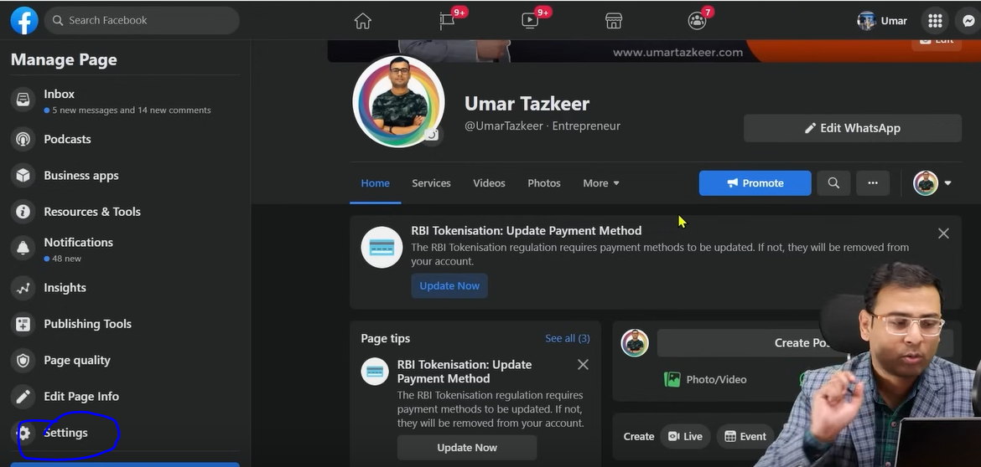

Go to your Faceboo side manu and there go to settings as marked above

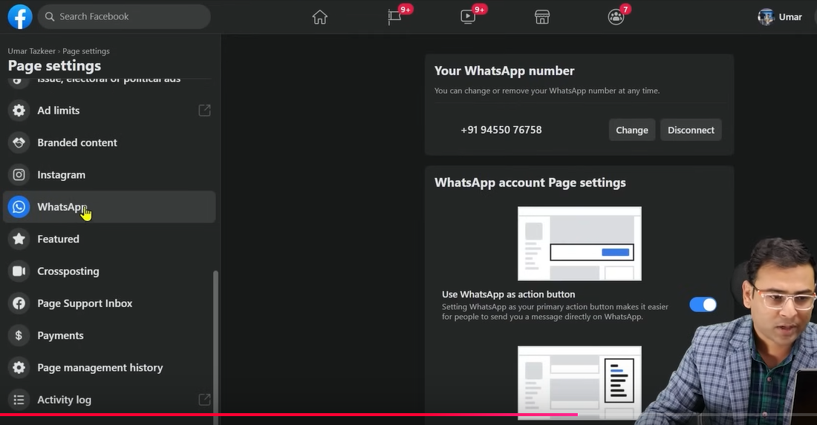

Now in new page side menu go to Whatsapp

And then in right you can see Teacher wahtsapp number as it is cionnected with the page if it si not onnected then it will show you option to connect it.

SO this is the first step you have to do.

Now we will see how to generate lead through message campaign

From teachers perspective

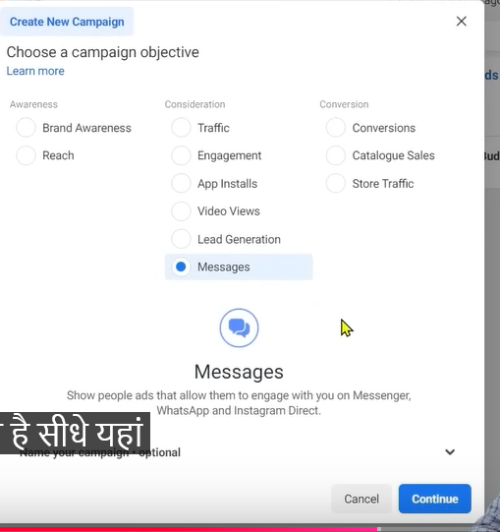He choose message but in new UI it comes under leads

So we go to choose leads instead and then click on continue

Now we are in Destination section in ad set level

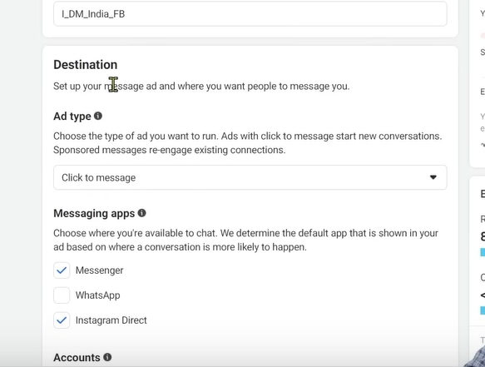

IN messageing apps subsection(where you will choose your receiver choose whatsapp you can chosoe all if you want but in this particular case facebook system decide in which destination the user will go after clicking on the ad.

Means facebook ad system will judge the user and analyse him by messaging on which app increase the chances of convergence So call to action contains the link to the app who have higher chances where convergence can happen It can be whatsapp , Instagram.

But I am here ompletely sute that we want ot show ad for whatsapp only so we only choose whatsapp

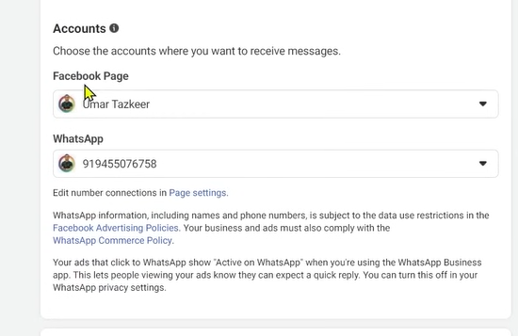

Now in Accounts section choose the page and then choose your what app contected to this page (maybe)

In my UI it is like this

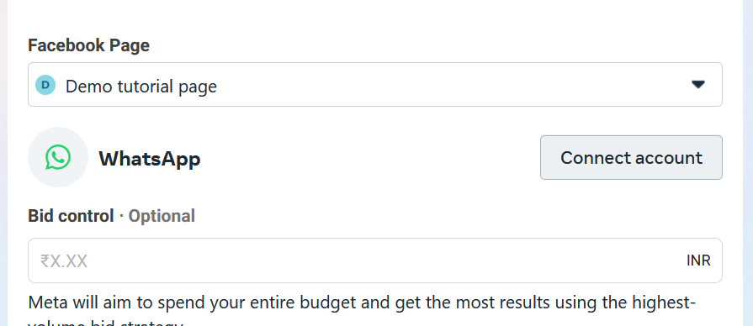

Now we will set the placement, budget and detail targeting, allocate budget

In ad set we will make different variation of ads for different purposes.

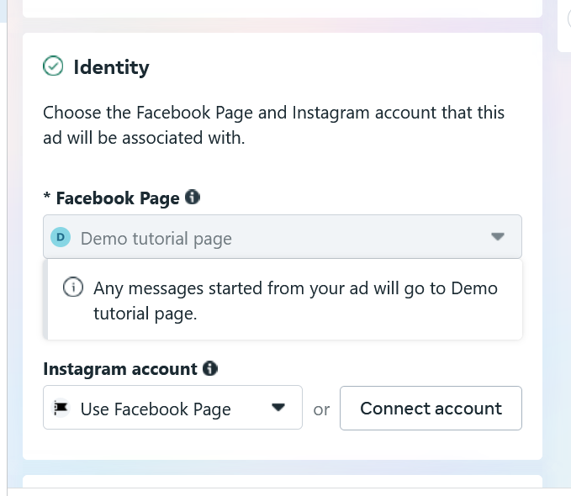(my UI)

In ad set level and then identity section

Here our identity is selected

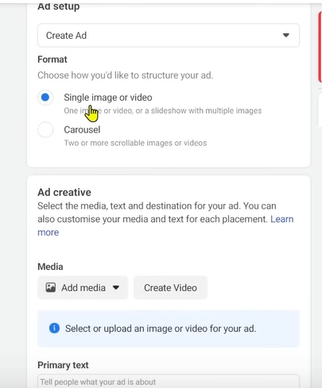

Now in adsetup single image is chosen and then we add an image here for the ad preciously studied

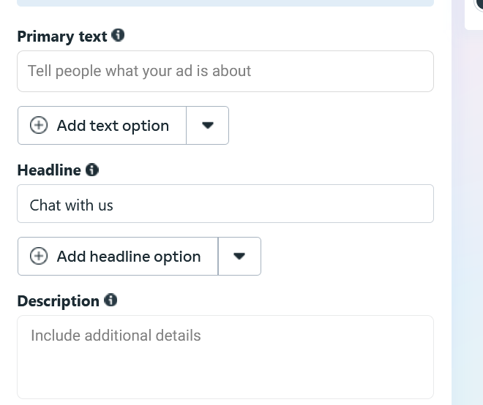

Headlines usually comes with chat with us since it will open a messaging app.

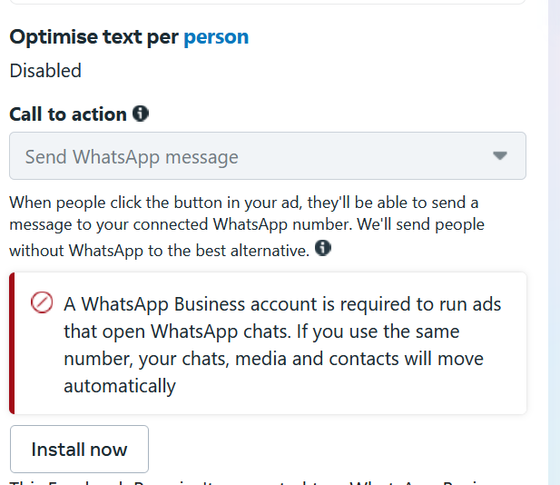

And call to action is “Send Whatsapp message”

Now in message Template

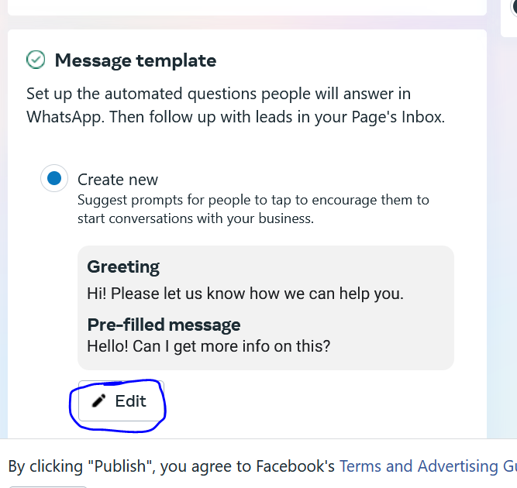

Choose edit button as marked above

This is when the user will interact with the ad a small type of form will be opened as previously discussed so that we get quality leads

Normally after clicking on ad and reaching whatsapp he can keep it blank and converstion does not get started and be backed out

Now click on Edit as marked above

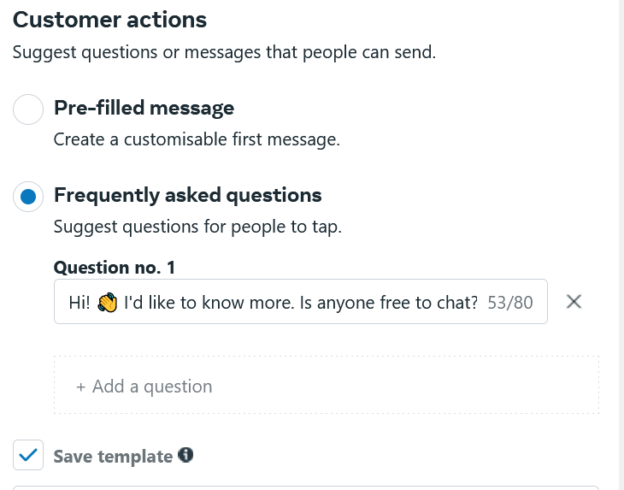A small window will be opened

Now we choose frequently asked question

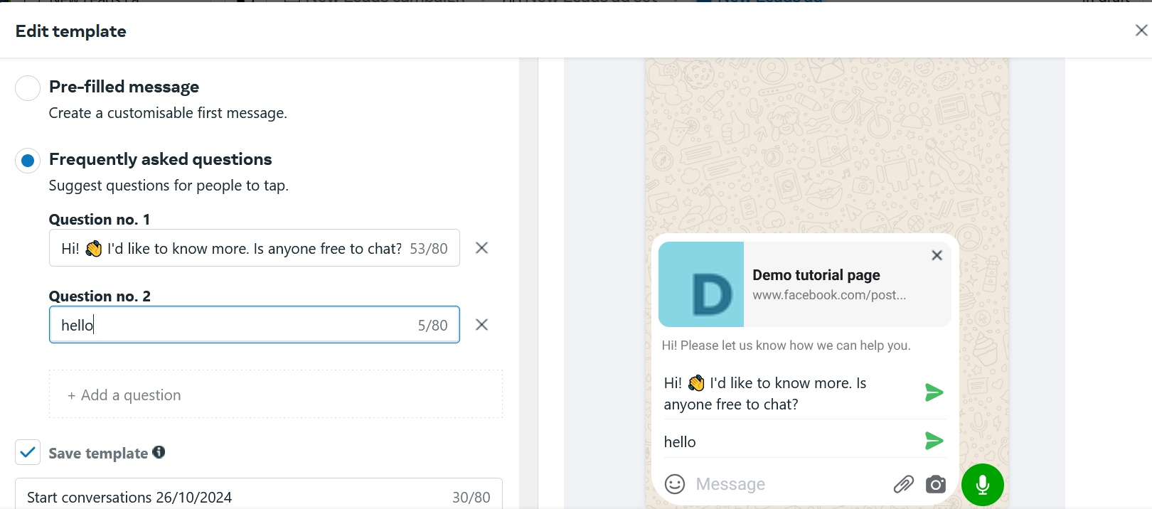

I cannot understand this maybe these are the question that the customer may choose to ask to us or maybe he can write his ouwn message below the option shown(whi knows) 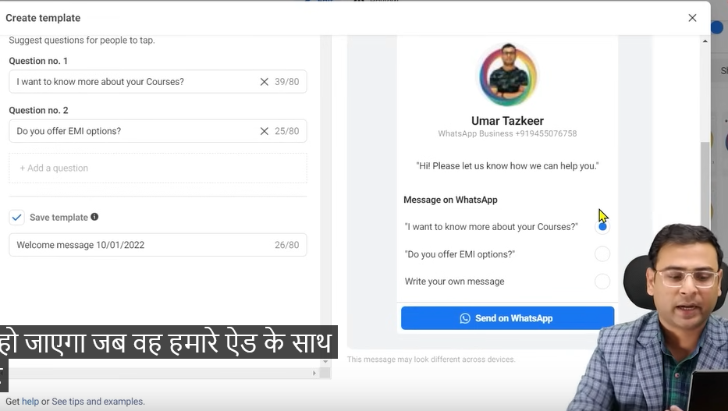

From teacher perspective

So by this a form will be opened

**Phase 70**

when he will interact with our ad

Now we have given an option to the user means before the conversation and after ad interaction in between there which basically make sure the encourage us to talk there should be no blank

So from this point of view it is preferred that that we run ads through message because we get this option here but onn the other hand by traffic you did not get thid message another thing you can do after adding question you can save this template

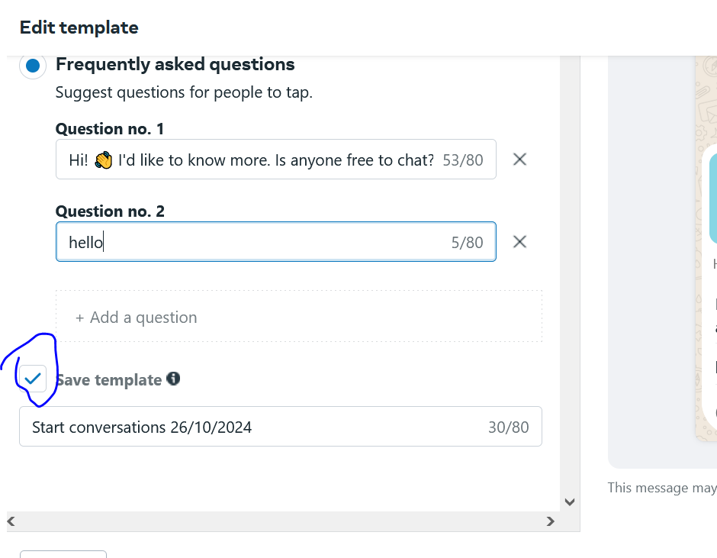by checking the above marked

And then you can test these different templates

So when he choose any option then that message will be sended to us.

So this way a communication will be started and message purpose is that the communcation should be started properly

Now suppose

We make a traffic campaign and ten reach ad set level and then choose Whatsapp in Traffic section

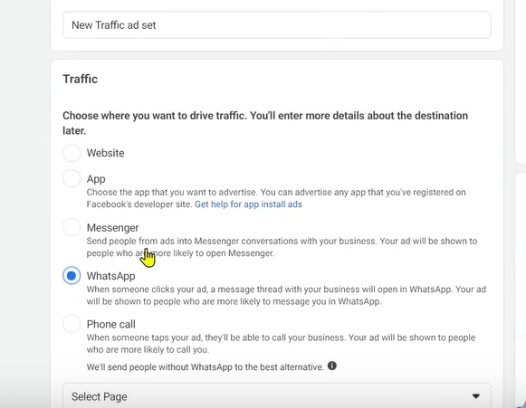

Meas we want to bring traffic to website

Now in ad level after adding creatives, placement

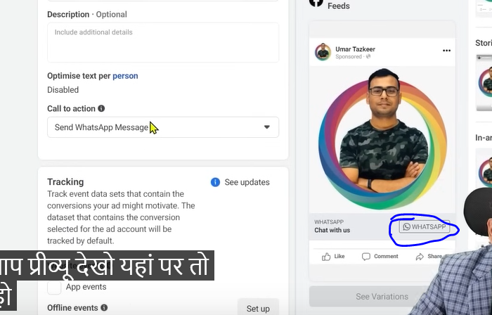

You can see the whatsapp as marked but not the template

The benefit we get by the options of questions we don’t get it here.

So if we want quality leads then we use messages option and ten through template and we will make Template through it and will bring traffic through it

Targeting option remains the same it is same in all the campaign

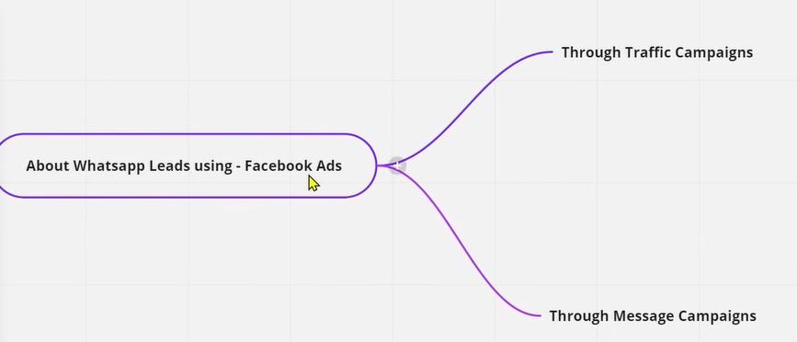

Teacher recommend us Message Campaign. Through this you can generate better quality leads

**Lesson 55:-**

In this lesson we will learn about **How to create Call-Only Ads in Facebook**

Our focus is here is that when our targeted audience click on the ad then a dialer will opened with our number and they can call us .This time we don’t want to generate lead by forms or by Whatsapp messages we just want that they directly call us. We want to run Call Only ads campaign

Now we will see how to run the campaign through facebook ads

Then there are two objectives we see.

First id Traffic Campaign objective

And another is Lead Generation Campaign

By using both of them we can run call by ads objective

Teacher recommend us to run call ads by Lead Generation Campaign

The reason behind this is Because this objective is on the basis of that you get more and more Calls but in traffic the optimization is on the basis of LinkClick

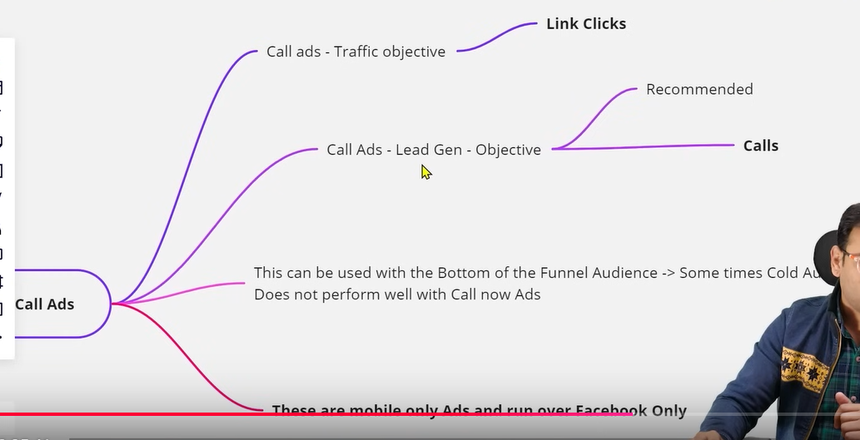

In lead gen you can get quality ads easily

Many people say they run the ad but they did not get good result

It is seen that when we run ads on the basis of saved audience we don’t get good result there until of unless your offer is not good

Try to understand this thing is that for example you are running a call ad ad you show the ad to your targeted audience which is save audience and below this you give the option of call now

Why that person will call you when that person don’t even know you Who hav not visited your website earlier and don’t know about your services

It is seen very rarely that the person come in the influence of

Creatives. Means This can be that we are not getting quality leads Generally it is seen success of call ads increased when we use bottom of the funnel in them Means we can use them with remarketing audiences or we are making audience who viewed our page or we used instagram page audience

If we show these type of ads to these people along with some offers

And if you are running your ad for saved audience then make sure your offer is very attractive and you have mentioned your offer in your ads properly then it increase the chances that you will get relevant and quality ads

We will see how ti setup this campaign under lead generation campaign

And another important point is that this is Mobile Only ads and they run only on Facebook

If you want them to run on messenger or in instagram or run in Audience network so her the audience get narrowed down by default because here you run ads on only mobile devices

Now go to campaign creation window choose Lead We will see traffic later

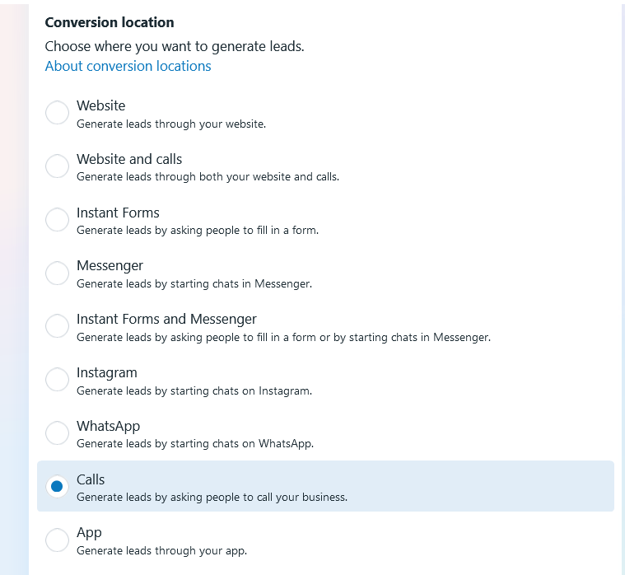

Now in conversation location choose Calls

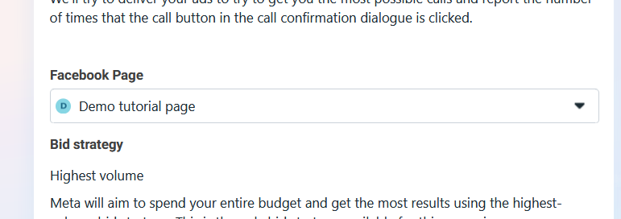

Now choose pages

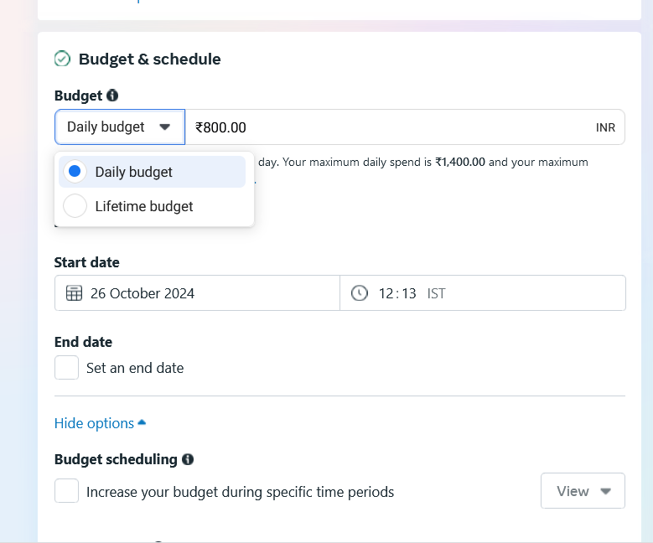

And in budget you can set your budget according to daily or Lifetime If we set lifetime by 15000 and we run for ad for 15 days then our average daily budget will be 1000 rupees approx.

We are talking about them here because you get the option of ad scheduling in the lifetime budget only. We need ad scheduling because in Call ads we have its requirement because now suppose we run ads from 10:00 AM to 6:00 PM and

**Phase 71**

Beyond that we don’t want that we get our calls and in that we want that our ads should run for a specific period of time we can schedule it to run in specific ads

We don’t see such thing in daily budget even if we choose Daily budget.

We discussed this option because while running call ads we sometimes talk about this that we want to run our ad in such a way which will not be run throughout the day.in different scenerios

We will set the target Audience and then we set the Manual Placement.

And now in Manual Placement

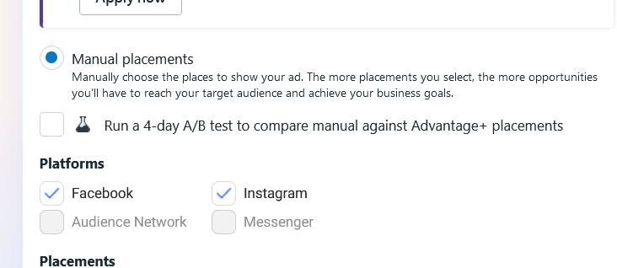

You can see Audinece Network and Messenger is deactivated

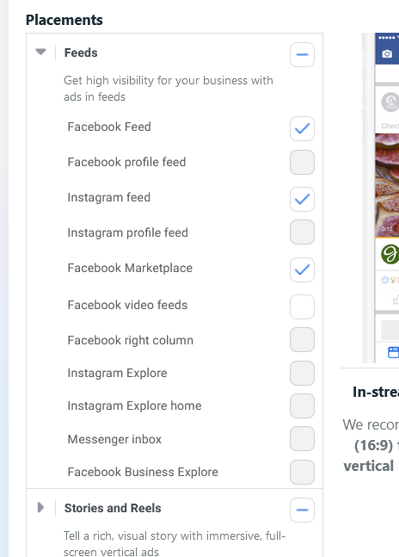

In feed Only marketplace, Instagram Feed ,Marketplace is selected

From Teacher Perspective

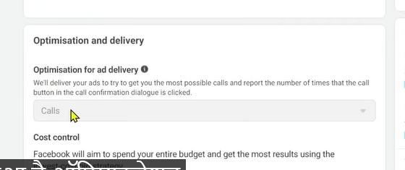

In optimization for ad delivery Calls is selected by default

Note this thing

Now we go to ad level. Now in ad level choose your creative

And in identity section chose page.

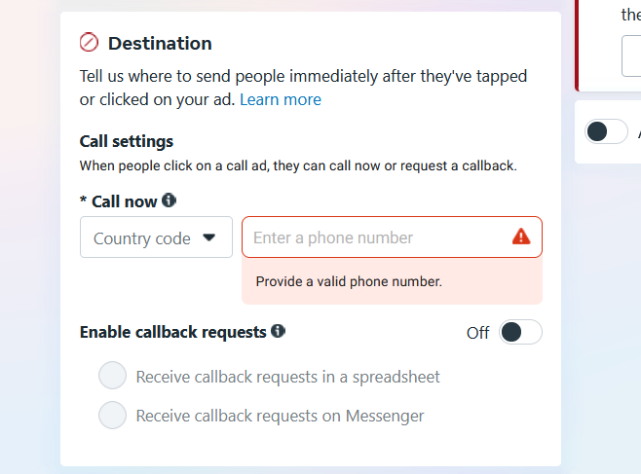

Now in Destination section tell your phone number

Thats how you set up it (who knows)

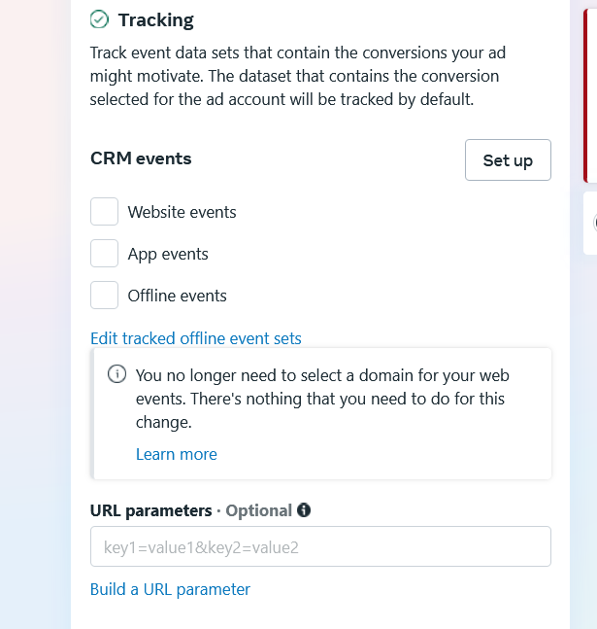

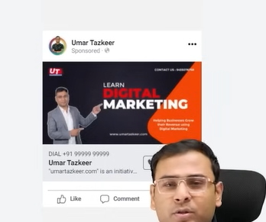

You can ssee the preview as shown above

Now anybody will click on call now then the dialer will be opened then he can call us directly

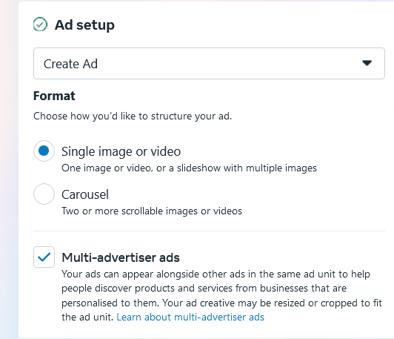

In format section it is given Single Image or Video or Corousal

It is seen that Single image creative perform better and make sure for testing use multiple images You can also use video if your want but teacher has seen that Teacher image performs better

Now we will se traffic campaign

As we know that Traffic campaign are majorly optimized for Link Clicks

So we create a traffic campaign and now reach ad set level

And now in conversion ection

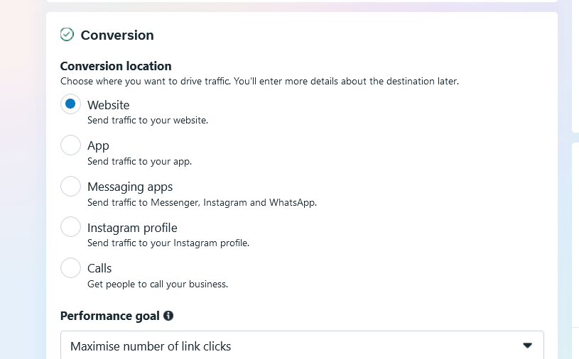

Here it is saying choose where you want to drive the traffic

You will see here two or three things are changed with respect you see in lead generation campaign

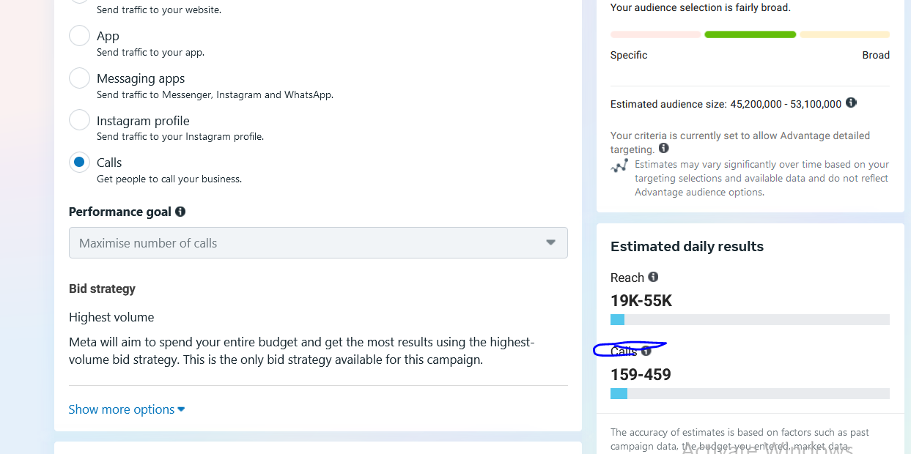

.

Now when you choose call is written as marked above

And Now in optimization and Delivery you can see it is showing Calls optimisation

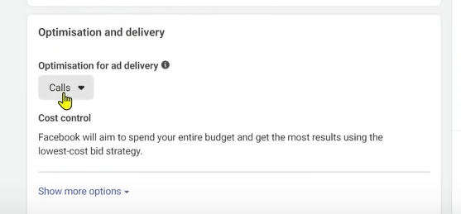

But overall this traffic campaign are optimised for Link Clicks.

So we say that Lead generation is better for phone ad.

**Lesson 56:-**

In this lesson we will learn about Instant experience in Facebook ads

We will see it in detail and see it from basic level

What is this this and how to create it.

If we have created an instant experience ad then if we want to see its success then what are the important metrics and how do we reach to that metrics We will see all these things in our lesson and we will see what are the pros and cons of it.

So first we will try to understand its meaning

Is this some type of new campaign that we run in facebook the answer is no

First we understand the this is an ad level concept

If we use this instant experience ad

It is also called canvas ad but this is not a famous name So if we are using instant experience ad

Now by using this what happens is that the image or creative used in our ad shown to the user and when they click on the page then they will not be directed to the landing page but a very fast mini landing page will be opened

<https://www.facebook.com/business/ads/instant-experiences-ad-destination>

to know more about it follow the above link

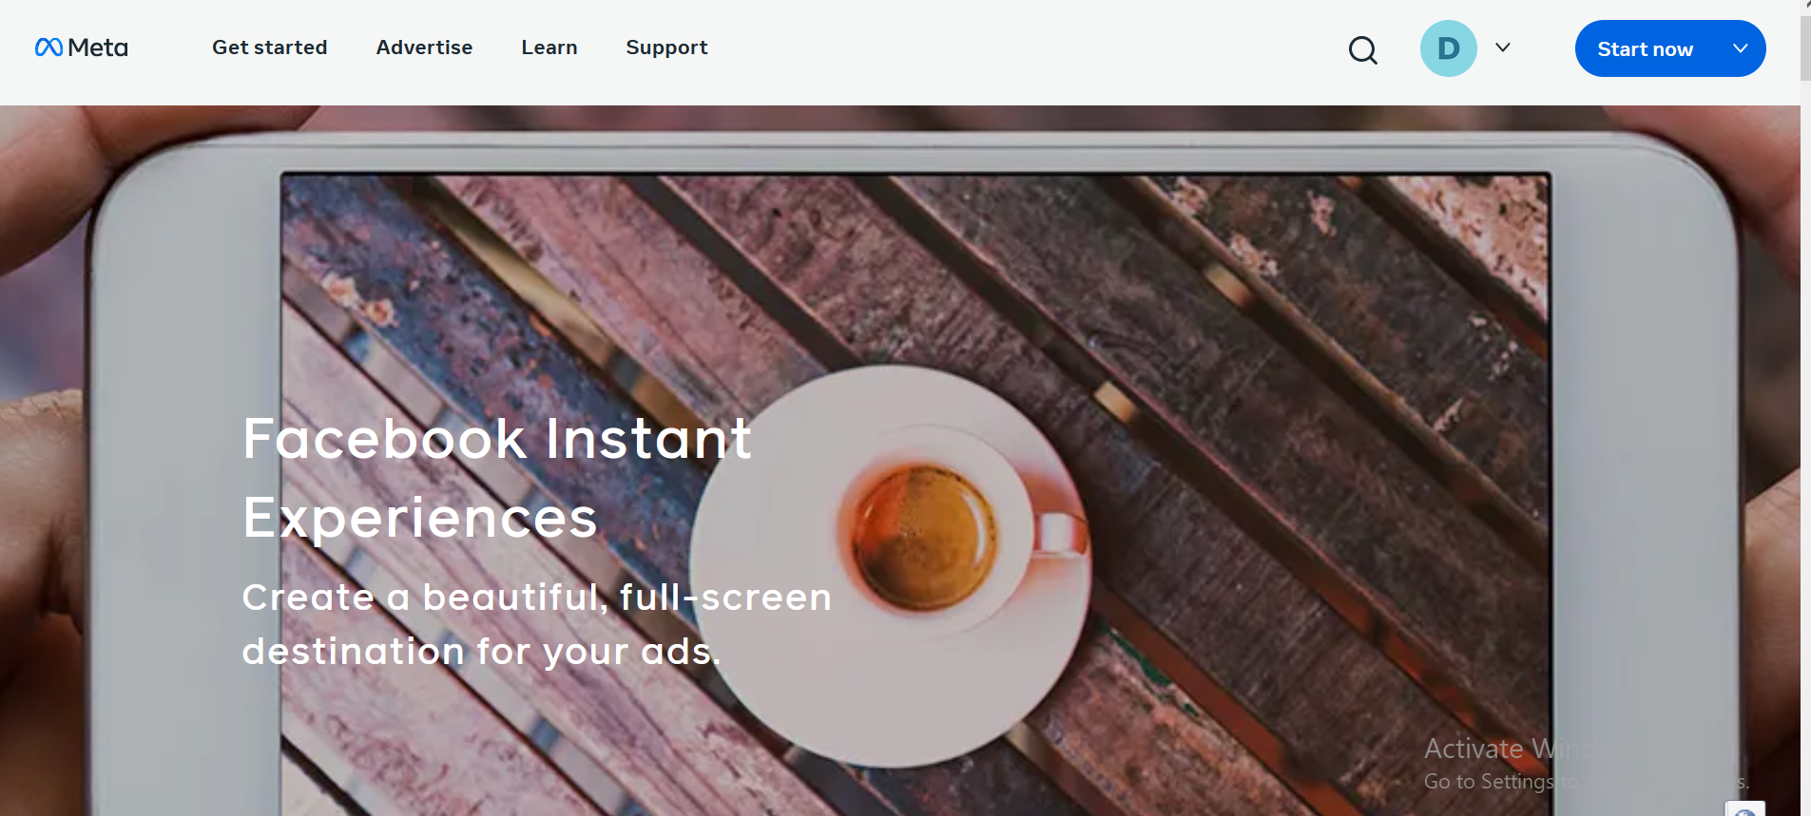

You can see the facebook instant experiences is written

Till now you used to see your landing page

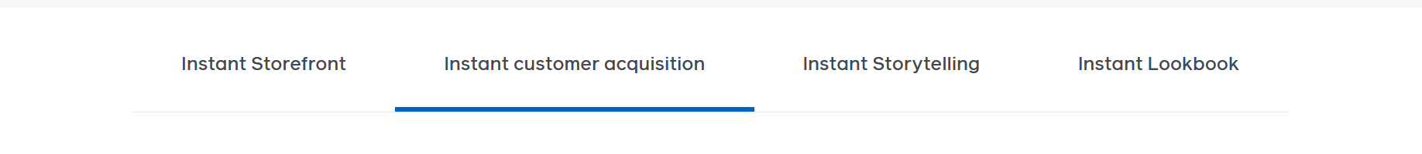

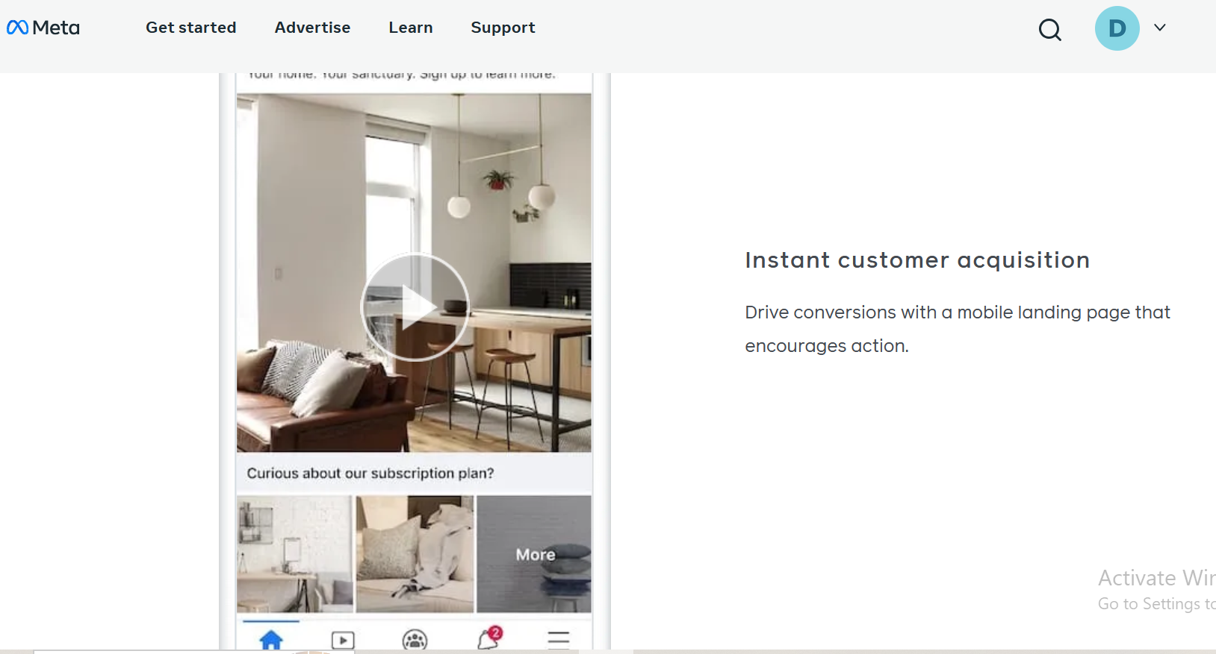

You see your ad like this

Now when you click on it then



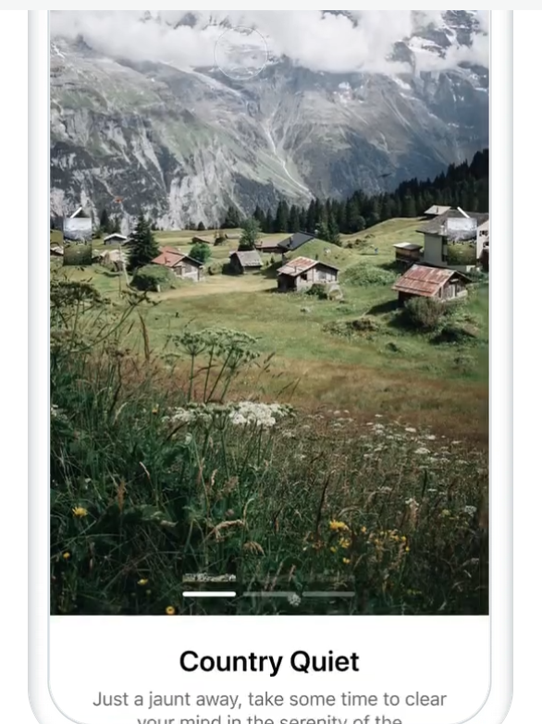

Something like this landing page will be opened as shown above

This is a mobile only thing

Now we are not making the audience going to landing page but in middle we are opening our mini landing page which is also Instant experience which we created so that we can give more information about the thing which we are marketing on the facebook iplatform

**Phase 72**

itself and the information we see in the instant experience we have lots of option like button if we want then we can redirect from the instant experiecen through button or link inside it (maybe)

SO basically it is an experience which gets added to the ad in the form of powerful

We can add corousel ,imges , videos like amini landing page there

S now we talk about its positive and negatives then see how to make it

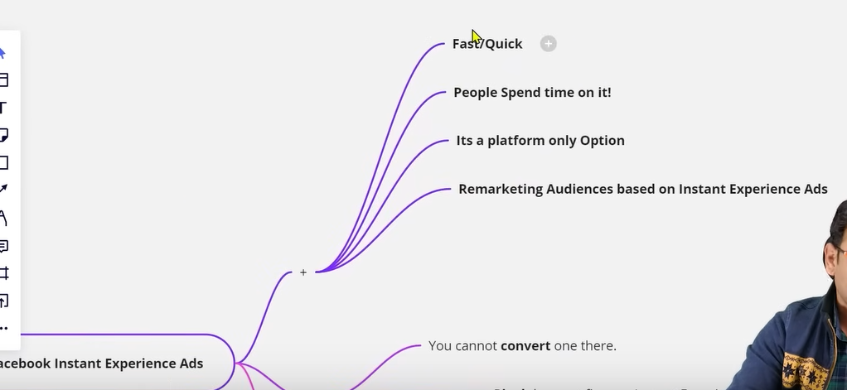

First benefit id that they are very fast

They spend time on it because they don’t have to go outside the Facebook interface people watch as they are not lengthy as it contains mostly 6 or 7 component

If you can do good storytelling and showcase your product in a better way. There are high chances that you can do convergence here.

Third point is that it is a platform only option means it is not like you can put this instant experiences in a landing page it will work only in facebook platform only

Fourth point is that we can create remarketing audiences based on Instant Experiences

By remarketing we mean who have engaged or opened instant experiences we can make audience on the basis of it.

You can see the Instant Experience in the audience creation window

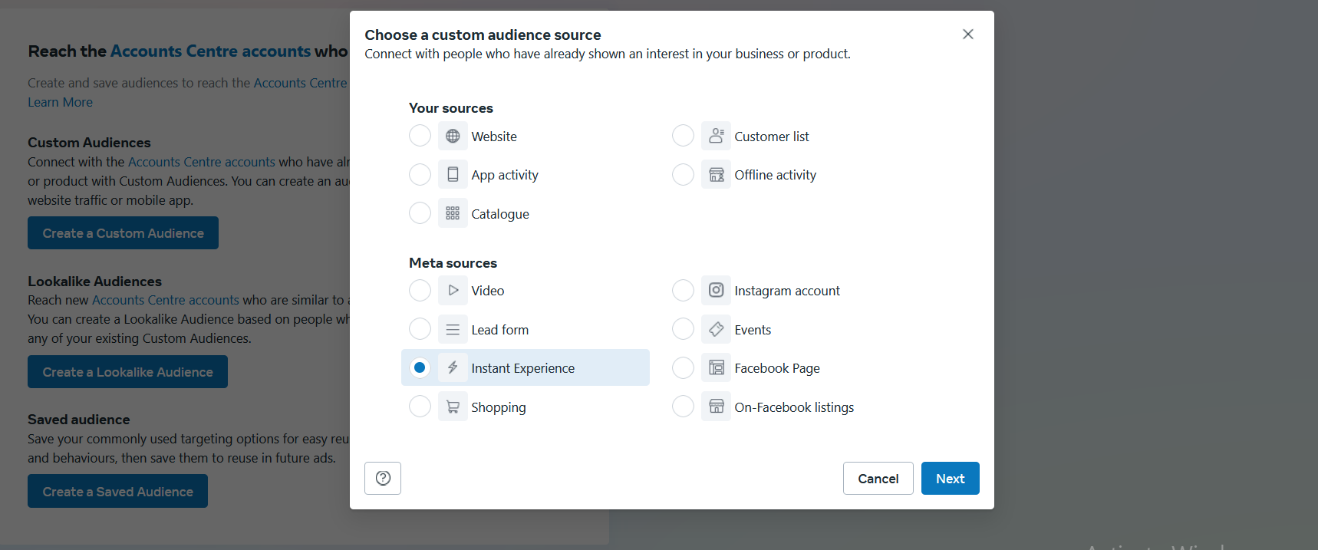

By clicking on next and then our mini panel will be updated

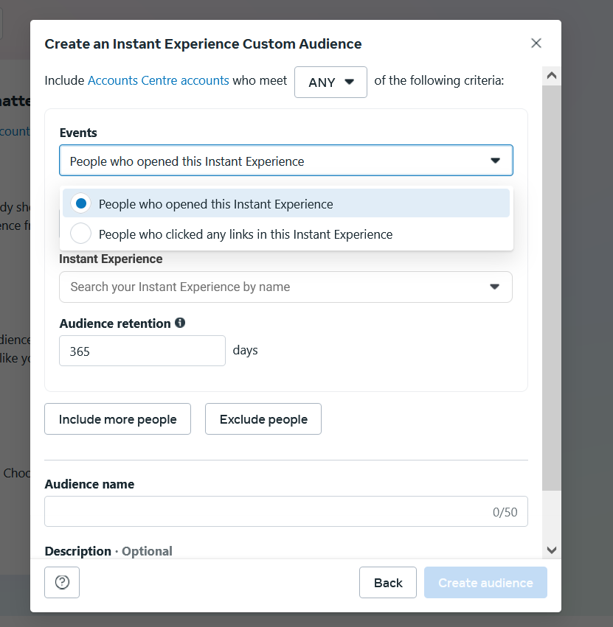

In the event field you see the two option

First is who opend it

And second who click on any link present in the instant experience ad Once this audience is made then its loklike audience can be made here

It has been told by the teacher that more the sources you have the more lookalike audience you can make

If you developed different sources of audiences then you will also have different testing opportunities

The patfor only is a pros because in todays time many people thinks that if we are taking our audience outside facebook means website and there is issues of IOS 14 and pixel are not working in a better way in such situation why not warm the audiences on the platform of facebook .There we will give information about our product in a better way so that later if we want to do convergence then we can take it to landing page because you cannot do convergence in your instant experience

Previously there was an option of instant form now there is no option of instant support means now it is not possible to add instant from.

The cons is like this

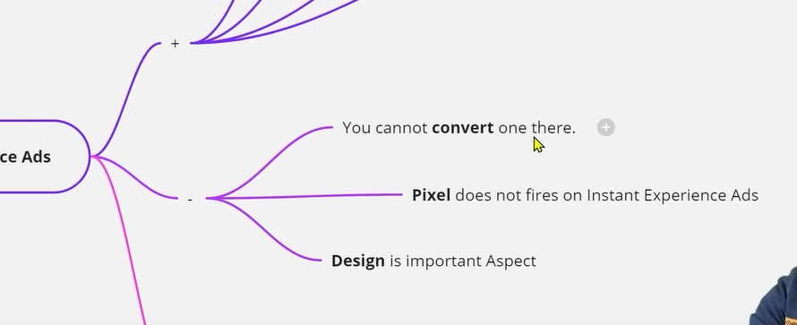

The first con is that you cannot convert here means it is not like that you can do sales here or make payment here

The second point is that you cann add pixel in it means you cannot create pixel based audience here.

But we can audience on the base of two events which we studied previously

Third point is subjective

Design is important aspect

How much better way you can design instant experience ad the success of your instant experiences depend on it.

If you have a better designer.or you can create good vreatives then you can see better result here.

There are two ways we can create it

First is by ad level

And if we want to create it from scratch then we have to go to our Facebook page and in the page we will go to publishing tool and then inside it we get the option of Instant Experiences and from there we create instant experiences there and then save it.

You can say it is a landing page that we will keep there and with time whenever you need this in an ad you can use it. It is similar to the way when you already save your lead form after creation for later use

First we will see it from ad level how to create it and what option do we get here and how many levels we can design it.

So now we will go to our ad account and then in your traffic campaign and in ad level as it is related to it

In ad level we choose

The page and the instagram account

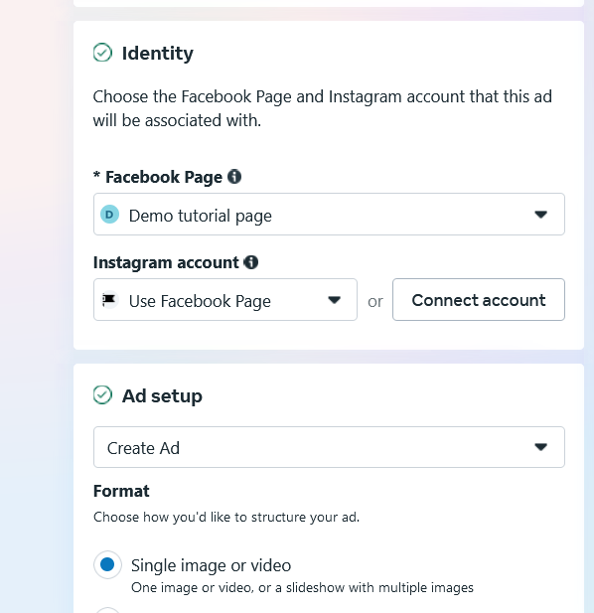

And now check the Add an instant experience(From Teacher perspective)

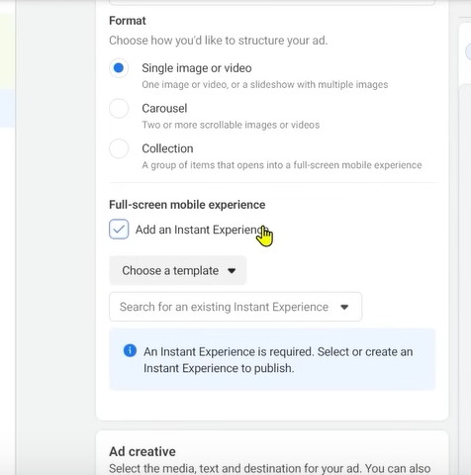

Now you can click on choose template to choose from template and if you want to create it from scratch then we can do so

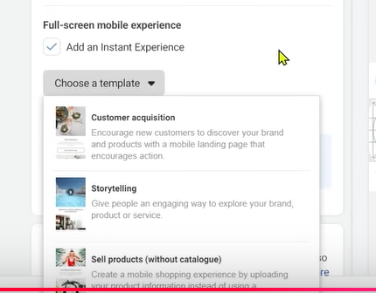

Now if we choose customer acquisition

When we clik on it a new window will open like this

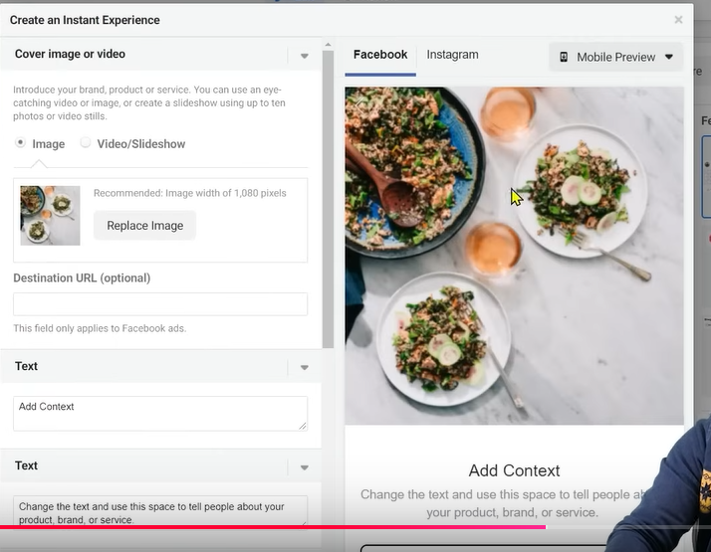

You can choose either image or video slideshow for your template

You can tell destination url which will be the url directed wgn the user click on the image

You can tell the text to be shown in your instant experience modify the call to action accotding to your need.

When you cose any temple it will ask you whether to discard the changes or save the changes.

It will be better if you do crate template from the scratch

Now we create instant experience through publishing tool in Facebook

Now we will go to Publishing tools in sidemenu as pointer above it

**Phase 73**

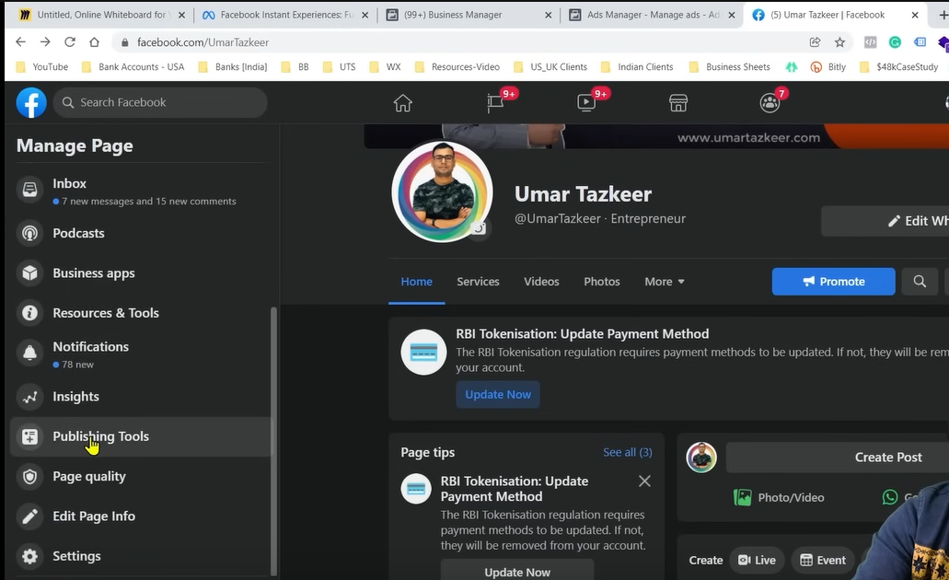

Now you will reach publishing tool page

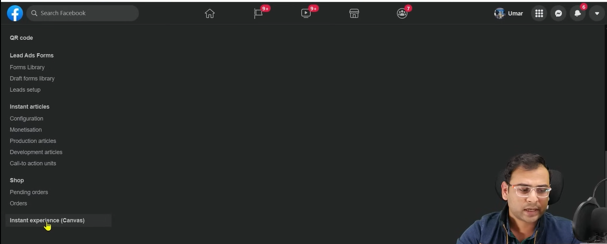

Now go in the bottom the page and in side menu click on the Instant Experience(Canvas)

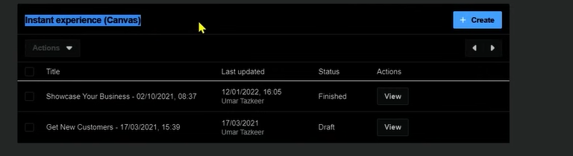

Now clickn on the create button

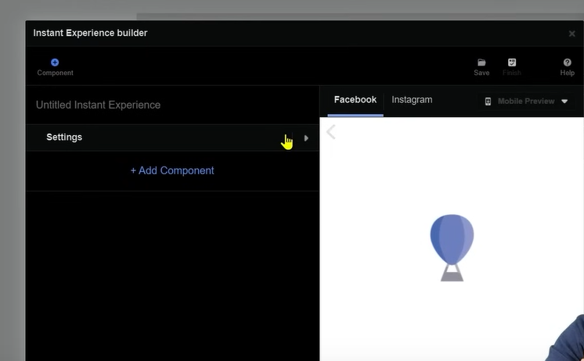

and from there you can create your template from scratch. So it is Instant ECperirnce Builder

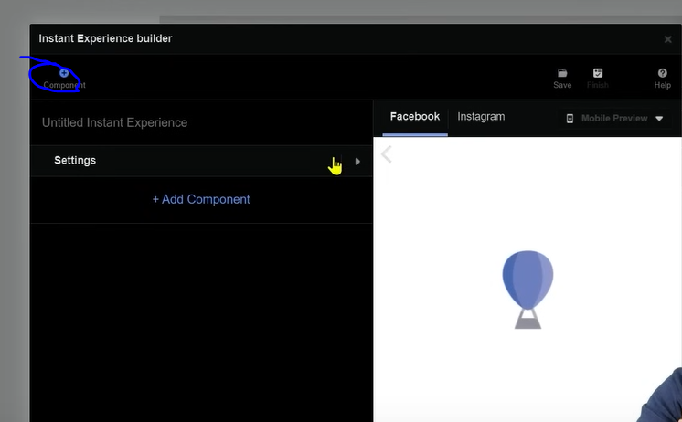

Now we click on Marked above to select the components to add

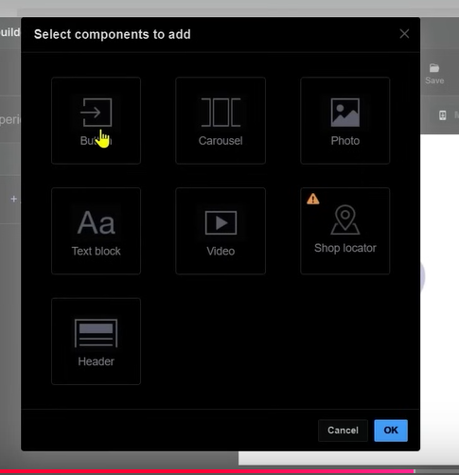

So we add component like button or carousal here.

Now if you choose button

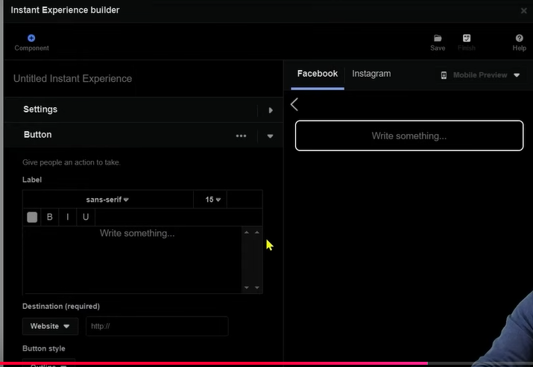

Then you can see in preview it is added now you can modify it by changing in the option shown in left

You can set its color or outline you can set its theme.

You can also add swipe to open

For Text Block we have below

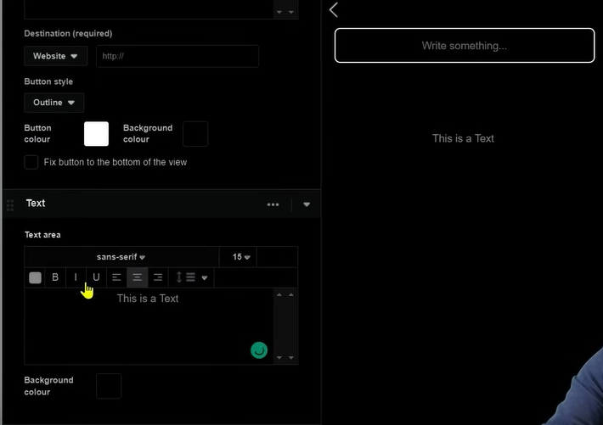

This is like a text field